Week 7 Virtual Binder Name _______________________ Per ____

Sjuts Office Hours: Tuesday-Friday 2:30-3:30 P.M. → https://lps.zoom.us/j/188685904
Smith Office Hours: Monday/Wednesday 12:30-1:30 P.M. and Friday 12:00-1:00 P.M → https://lps.zoom.us/j/8246353539

Objectives: Text Key Concepts
5. Compare & contrast the properties of different stars. | GS 30.2- 30.3 | Magnitude, Temperature, Brightness, Luminosity, Mass, Composition, HR Diagram  b=L/(4πd²), λT=2.90*10⁻³ m*K
6. Sequence & summarize the processes in the life cycle of the stars. | GS 30.3 | Nebula, Protostar, Main Sequence Star, Red Giant, Super Red Giants, White Dwarf, Black Dwarf, Red Dwarf, Neutron Star, Black Hole, Element formation
7. Compare relative distances and sizes of astronomical entities. | GS 30.2 | Astronomical Unit, Light year, Parsec, Relative distances between/radius of: Planets, Stars, Galaxies, Universe

Week 7 Virtual Binder Objective Work:
Objective 5:

Objective 6:

Objective 7:

Objective 5 Tasks:
- Read Ch 30.2 and use the Properties of Stars slides to supplement
- Complete Properties of Stars Notes

- Distance
  - Describe how astronomers use parallax to find distance. Insert an image. What limits the use of parallax?

  - What are common units of distance in astronomy? (see objective 7)
- Mass
  - Describe how astronomers determine the mass of stars in the binary using binary stars.
  - How common are binary stars in the Milky Way galaxy?
- Temperature/Color
  - Describe two ways a flame is similar to stars.
  - What color star has more energy? Less energy?
- Brightness
  - Apparent Magnitude –
  - Absolute Magnitude –
  - What is a limiting factor of absolute magnitude?
  - Luminosity (L) –
  - Apparent Brightness (b) –
  - Compare and contrast luminosity and apparent brightness. Include units.

  - Insert an image of a Hertzprung-Russell Diagram. You will use the image to answer the questions below.
    - What factor affects the color of a star?
    - What factors affect the luminosity of a star?
    - What is the approximate surface temperature of the sun?
    - Is the surface temperature of white dwarf stars higher or lower than red supergiants?
    - List the color of the stars from hottest to coldest:
    - Most of the stars on the HR Diagram are classified as which type of star?
    - What type of star has a high temperature but a low luminosity?
    - What type of star has a low temperature but a high luminosity?
  - Variable Stars –
    - Cepheid Variables –
    - Nova –
Objective 6 Tasks:
- Watch the Life and Death of a Star and use Ch 30.3 and the Star Life Cycle slides to supplement
- Complete the Star Life Cycle Practice

Section One - Sequencing
The stages below are not in the right order. Number the stages in the correct order.

_____ The star begins to run out of fuel and expands into a red giant or red super
giant.
_____ Stars start out as diffused clouds of gas and dust drifting through space. A single
one of these clouds is called a nebula
_____ What happens next depends on the mass of the star.
_____ Heat and pressure build in the core of the protostar until nuclear fusion takes place.
_____ The force of gravity pulls a nebula together forming clumps called protostars.
_____ Hydrogen atoms are fused together generating an enormous amount of energy igniting the star causing it to shine.
Section Two - Vocabulary
Match the word on the left with the definition on the right.

____ black dwarf e. star left at the core of a planetary nebula
____ white dwarf g. a red supergiant star explodes
____ nebula c. what a medium-mass star becomes at the end of its life
____ protostar b. a large cloud of gas or dust in space
____ supernova a. exerts such a strong gravitational pull that no light escapes
____ neutron star d. the earliest stage of a star ’s life
____ black hole f. the remains of a high mass star

Section Three – Understanding Main Ideas - Low Mass Star
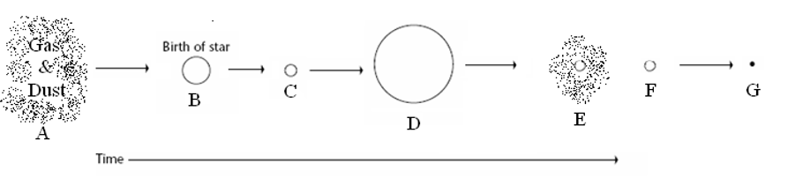
____ 1. Red giant
____ 2. Where fusion begins
____ 3. Nebula
____ 4. Black dwarf
____ 5. The stage the sun is in
____ 6. White dwarf
____ 7. Planetary Nebula

Section Four – Understanding Main Ideas - High Mass Star
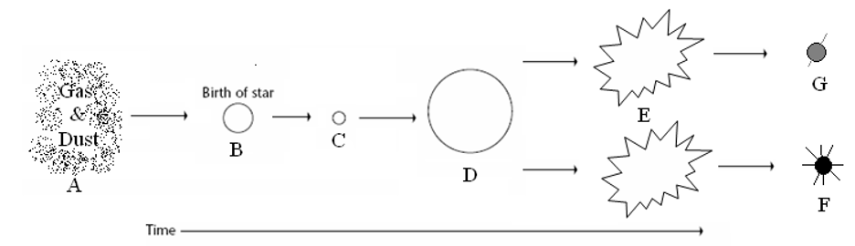
____ 1. Black Hole
____ 2. Supernova
____ 3. Protostar
____ 4. Gravity causes this to condense into a protostar
____ 5. Main sequence star
____ 6. When a star begins to run out of fuel and grows larger
____ 7. Neutron star
Section Five – Graphic Organizer – Putting it all Together
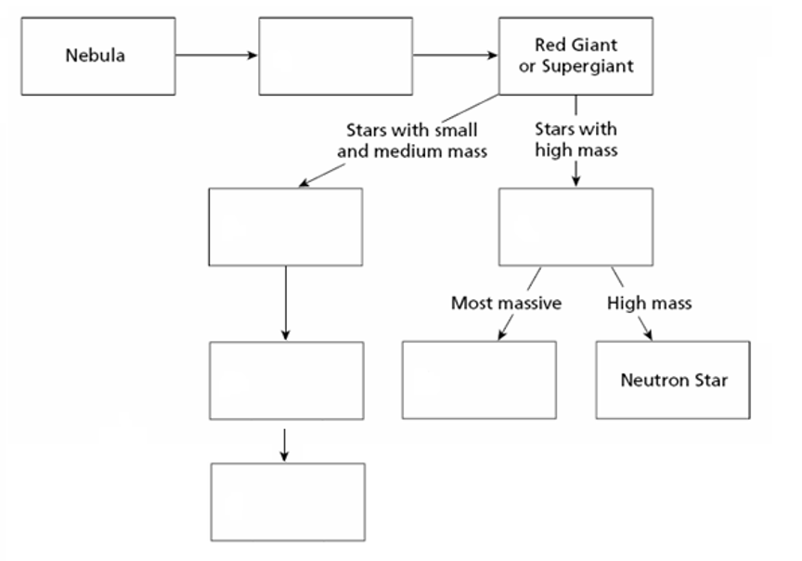

Section Six – Venn Diagram - Compare and Contrast
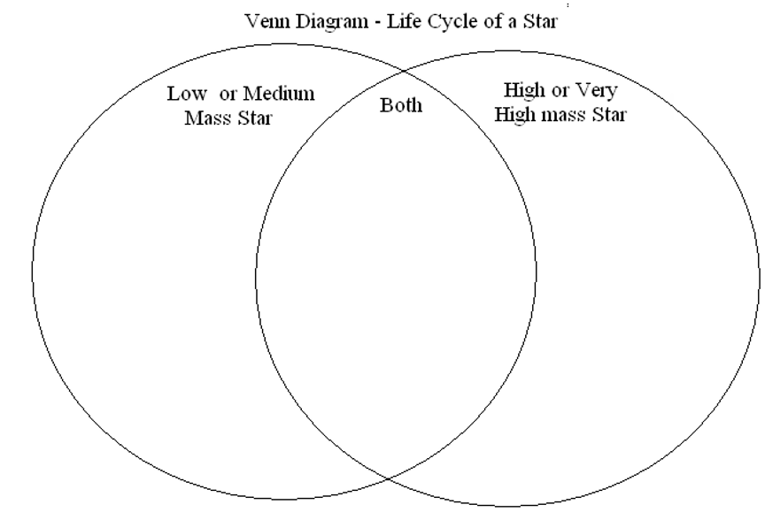

Objective 7 Tasks:
- Investigate the Scale of the Universe animation. Allow Flash!

Reflect: What surprised you? What interested you? What was cool?

