Week 6 Virtual Binder Name _______________________ Per ____

Sjuts Office Hours: Tuesday-Friday 2:30-3:30 P.M. → https://lps.zoom.us/j/188685904
Smith Office Hours: Monday/Wednesday 12:30-1:30 P.M. and Friday 12:00-1:00 P.M → https://lps.zoom.us/j/8246353539

Objectives: Text Key Concepts
3. Describe the structural organization of the solar system. | GS 29.4 | Sun, Planets, Terrestrial, Jovian, Asteroid belt, Kuiper belt, Oort cloud, Comets, Meteoroids
4. Explain each of Kepler’s Laws and apply them qualitatively. | GS  29.1 | Eccentricity, Semi-major axis

Week 6 Virtual Binder Objective Work:
Objective 3:

Objective 4:

Objective 3 Tasks:
- Read Ch 29.4 and watch the video to supplement: Birth of the Solar System (47:29)
- Complete Solar System Organization Activities
- Planet Characteristic Chart - You likely know a fair amount about our solar system. Fill in the chart with the choices given. Use the Resource Link (allow Flash) as needed.

 | Size  Lg / Sm | Density  High / Low | Atmosphere  Thick / Thin | Main Composition  Rock & Metal / Gas & Ice | Gravity  High / Low | Orbital Velocity  Slow / Fast | Orbital Period  Long / Short
Mercury
Venus
Earth
Mars
Jupiter
Saturn
Uranus
Neptune

- Solar System Scale – Click the Scale Link to compare the distances between planets to a football field. Then watch the Solar System to Scale Clip (7:21).
Write a few sentences reflecting on the sale of the solar system.

- Solar System Formation - Describe what happens at each step in the process. Insert an image.
Notes and Sketches - Ch 29.4 Link to Resource
1. Nebula Collapses
2. Nebula Spins
3. Sun Forms
4. Planetesimals Form
5. Planets Form

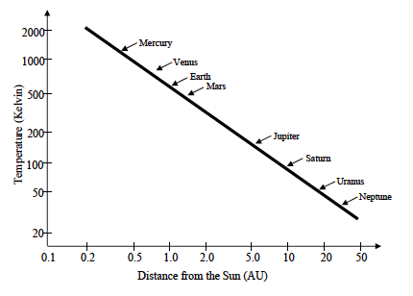
D. Temperature & Formation of Our Solar System
Introduction:
During the formation of our Sun and the surrounding planets, there is a definite line at about 3 AU from our Sun (an AU – Astronomical Unit – is the average distance between Earth and Sun), when it was cold enough for hydrogen and helium gas to freeze into ice pellets. Closer to the Sun than this, hydrogen and helium stays in gaseous form whereas farther than this, hydrogen and helium freeze. This impacts what our planets are predominantly composed of.
Instructions:
Consider the information provided in the graph. It shows the temperature (expressed in Kelvin) at different distances from the Sun (expressed in astronomical units or AU) in the solar system during the time when the planets were originally forming. Look at pg. 794-5 in your GS book as an additional resource.

Reflection Question: Does this make sense based on what you know about melting point, boiling point, and the elements on the Periodic Table?

E. Exoplanets - planets that orbit around other stars. Do they exist? Is our solar system normal compared to other solar systems?
Find an article that interests you about exoplanets. Paste the link here, and explain why it caught your attention.

Read the article. Is our solar system normal?

Objective 4 Tasks:
- Read Ch 29.1 and watch the three video clips on Kepler’s Laws to supplement: Law 1(3:18), Law 2 (3:35), Law 3 (5:54)
- Summarize each of Kepler’s Laws with a paragraph.
Kepler’s 1st Law:

Kepler’s 2nd Law:

Kepler’s 3rd Law:

