Wave Particle Duality of Light - 2019 Name: Per:
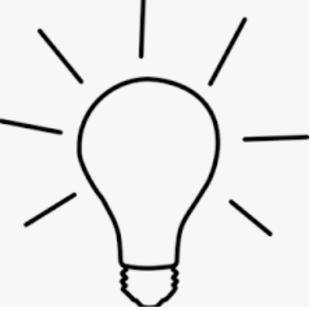
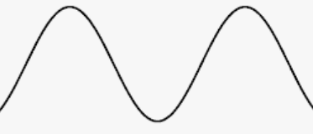
OR

- What behaviors in the image suggest that light is a wave? Explain.

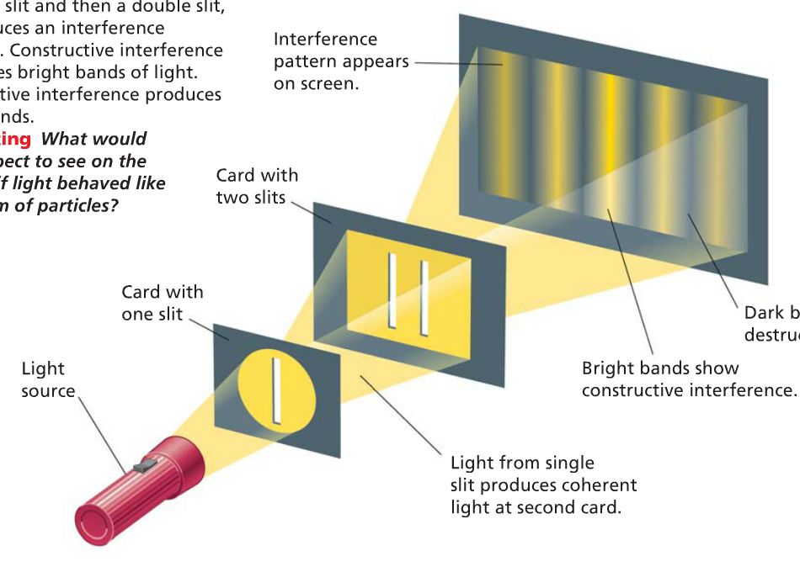

- What behavior suggests that light is a particle?
- What do you call a “particle” of light?
- What is the photoelectric effect?
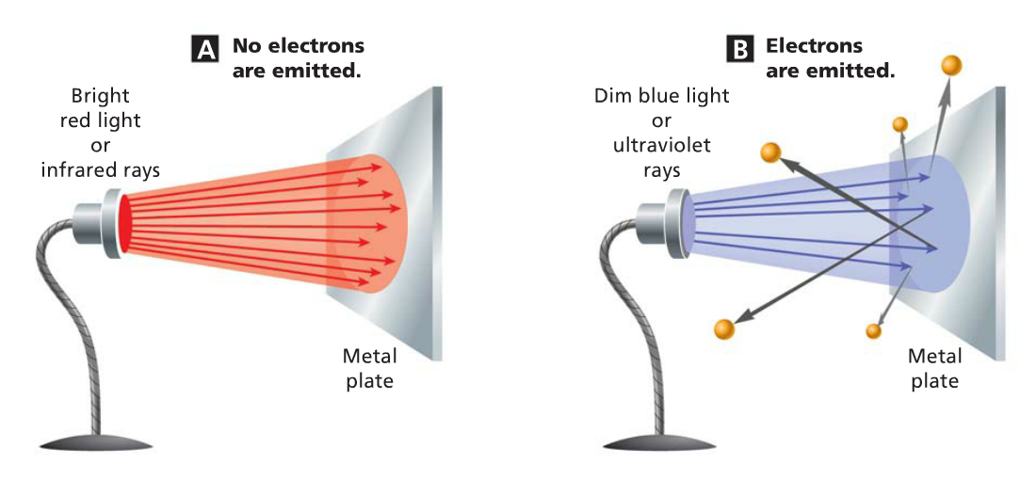
- Why are electrons emitted in image B (blue light) and not in image A (red light)?
- What is a real-life application of the photoelectric effect?

