Tour of the Electromagnetic Spectrum via NASA Name ________________________
https://science.nasa.gov/ems/01_intro Period _________ Date _________

- INTRODUCTION TO THE EM SPECTRUM

- What are atmospheric windows? Why do they exist?
REGIONS OF THE EM SPECTRUM WITH WAVELENGTHS THAT CAN PASS THROUGH THE ATMOSPHERE
SOME EM RADIATION IS REFLECTED OR ABSORBED BY GASES IN EARTH’S ATMOSPHERE (WATER VAPOR, CARBON DIOXIDE AND OZONE). SOME RADIATION PASSES THROUGH.
- Why is it necessary to have space-based instruments to study sources of high-energy radiation in space?
INSTRUMENTS NEED TO BE POSITIONED ABOVE EARTH’S ENERGY-ABSORBING ATMOSPHERE TO “SEE” HIGHER ENERGY AND EVEN SOME LOWER ENERGY LIGHT SOURCES SUCH AS QUASARS.

- ANATOMY OF AN EM WAVE

- How are EM waves created? What do they carry?
EM WAVES ARE CREATED BY THE VIBRATION OF CHARGED PARTICLES AND CHANGING MAGNETIC OR ELECTRIC FIELDS. A CHANGING MAGNETIC FIELD INDUCES A CHANGING ELECTRIC FIELD WHICH CREATES AN EM WAVE. (AND VICE VERSA) THESE WAVES DO NOT NEED A MEDIUM. THEY CARRY ENERGY ONLY.
- Describe the nature of EM waves. Use the key terms electric field and magnetic field.
A CAHNGING MAGNETIC FIELD WILL INDUCE A CHANGING ELECTRIC FIELD (VICE VERSA) WHICH CREATES EM WAVES
- Why are different EM waves described in different units? ie. Radio and microwaves - frequency (Hz), infrared and visible light – wavelength (m), x-rays and gamma rays – energy (eV)
ALL 3 ARE MATHEMATICALLY RELATED. IT ALLOWS THE CONVENIENT USE OF UNITS THAT HAVE NUMBERS THAT ARE NEIGHTER TOO LARGE NOR TOO SMALL.
- Describe the shortest and longest wavelengths of the EM spectrum according to the site.
SHORTEST – FRACTIONS OF THE SIZE OF AN ATOM
LONGEST – LARGER THAN THE DIAMETER OF OUR PLANET

- WAVE BEHAVIORS

- What can happen when light encounters an object? What determines the behavior?
TRANSMITTED, REFLECTED, ABSORBED, REFRACTED, POLARIZED, DIFFRACTED, SCATTERED DEPENDING ON THE COMPOSITION OF THE OBJECT AND THE WAVELENGTH OF THE LIGHT.
- Describe reflection. Draw a picture. Give an example.
LIGHT HITS AN OBJECT AND BOUNCES OFF. THE COLOR OF AN OBJECT IS THE WAVELENGTH THAT IS REFLECTED, WHILE ALL OTHER WAVELENGTHS ARE ABSORBED.
USED TO MAP THE TOPOGRAPHY OF THE MOON – THE LONGER IT TAKES FOR THE LIGHT TO REFLECT AND COME BACK TO EARTH, THE LOWER THE ELEVATION, TELESCOPES, ECHOS, MIRRORS, RADAR, RECORDING STUDIO?,
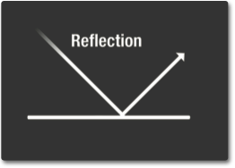

- Describe absorption. Draw a picture. Give an example.
ABSORPTION IS WHEN PHOTONS FROM LIGHT HIT ATOMS AND MOLECULES CAUSING THEM TO VIBRATE. THE MORE THEY VIBRATE, THE HOTTER THE OBJECT BECOMES. THE HEAT IS EMITTED FROM THE OJBECT AS THERMAL ENERGY. (DARK ABSORB MORE AND LIGHT ABSORB LESS) THERMAL E RADIATES IN THE FORM OF LONGER WAVE INFRARED E.
“URBAN HEAT ISLAND” EFFECT CAN MAKE A CITY HOTTER BECAUSE OF THE ENERGY-ABSORBING ASPHALT AND ROOFS…

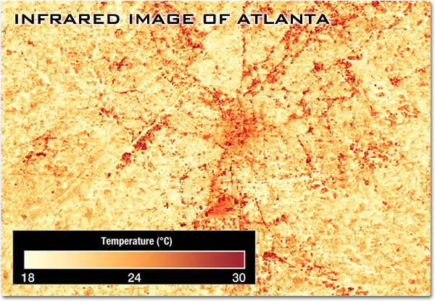

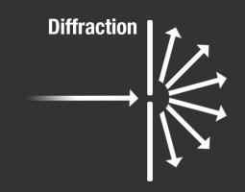
- Describe diffraction. Draw a picture. Give an example.
OBJECT CAUSES WAVE TO CHANGE DIRECTION AND BEND AROUND IT (OBSTACLE OR SLIT), DEPENDS ON SIZE OF OBSTACLE OR OPENING AND WAVELENGTH (longer wavelength = more diffraction, smaller slit = more diffraction), GREATEST SHOWMAN
TWEETS OF SONGBIRD VS HOOTS OF OWLS: tweets have shorter wavelengths, so they don’t diffract as much. Hoots have longer wavelengths, so they diffract more.

Spectrometers use diffraction (and interference) of light from slits or gratings to separate wavelengths. Faint peaks of E at specific wavelengths can be detected and recorded. A graph of these is called a spectral signature. Patterns in a spectral sig help scientists identify the physical condition and composition of stellar and interstellar matter. (temperature and composition).
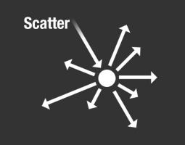
- Describe scatter. Draw a picture. Give an example.
LIGHT BOUNCES OFF AN OBJECT IN A VARIETY OF DIRECTIONS. DEPENDS ON WAVELENGTH OF LIGHT AND SIZE/STRUCTURE OF OBJECT. EX: SKY APPEARS BLUE
- Describe refraction. Draw a picture. Give an example.
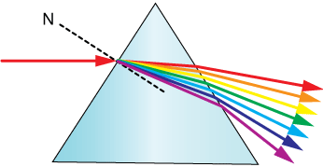
BENDING OF A WAVE AS THE SPEED OF THE WAVE CHANGES FROM ONE MEDIUM TO ANOTHER, ALWAYS ACCOMPANIED BY WAVELENGTH AND SPEED CHANGE
EX: SPEARFISHING, RAINBOWS, EYE GLASSES, FOG AND HEADLIGHTS, TELESCOPES

