HPS SOLAR SYSTEM FORMATION RESOURCES 2018

- Solar System Formation
Excerpt from “SOLAR SYSTEM GUIDE”
https://www.universetoday.com/15451/the-solar-system/
The Solar System formed 4.568 billion years ago from the gravitational collapse of a region within a large molecular cloud composed of hydrogen, helium, and small amounts of heavier elements fused by previous generations of stars. As the region that would become the Solar System (known as the pre-solar nebula) collapsed, conservation of angular momentum caused it to rotate faster.
The center, where most of the mass collected, became increasingly hotter than the surrounding disc (would become the Sun). As the contracting nebula rotated faster, it began to flatten into a protoplanetary disc with a hot, dense protostar at the center. The planets formed by accretion from this disc, in which dust and gas gravitated together and coalesced to form ever larger bodies.

- Inner vs Outer Planets
Excerpt from “SOLAR SYSTEM GUIDE”
https://www.universetoday.com/15451/the-solar-system/
Due to their higher boiling points, only metals and silicates could exist in solid form closer to the Sun, and these would eventually form the terrestrial planets of Mercury, Venus, Earth, and Mars. Because metallic elements only comprised a very small fraction of the solar nebula, the terrestrial planets could not grow very large.
In contrast, the giant planets (Jupiter, Saturn, Uranus, and Neptune) formed beyond the point between the orbits of Mars and Jupiter where material is cool enough for volatile icy compounds to remain solid (i.e. the frost line).
The ices that formed these planets were more plentiful than the metals and silicates that formed the terrestrial inner planets, allowing them to grow massive enough to capture large atmospheres of hydrogen and helium. Leftover debris that never became planets congregated in regions such as the asteroid belt, Kuiper belt, and Oort cloud.
Within 50 million years, the pressure and density of hydrogen in the center of the protostar became great enough for it to begin thermonuclear fusion. The temperature, reaction rate, pressure, and density increased until hydrostatic equilibrium was achieved.
At this point, the Sun became a main-sequence star. Solar wind from the Sun created the heliosphere and swept away the remaining gas and dust from the protoplanetary disc into interstellar space, ending the planetary formation process.
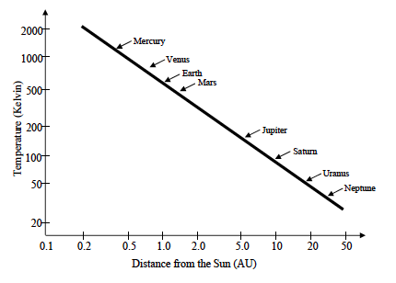
Temperature and Formation of Our Solar System
Introduction:
During for formation of our Sun and the surrounding planets, there is a definite line at about 3 AU from our Sun (an AU – Astronomical Unit – is the average distance between Earth and Sun), when it was cold enough for hydrogen and helium gas to freeze into ice pellets. Closer to the Sun than this, hydrogen and helium stays in gaseous form whereas farther than this, hydrogen and helium freeze. This impacts what our planets are predominantly composed of.
Consider the information provided in the graph and table to the right. The graph shows the temperature (expressed in Kelvin) at different distances from the Sun (expressed in astronomical units or AU) in the solar system during the time when the planets were originally forming.

- Football Field Scale of Solar System
https://www.nasa.gov/audience/foreducators/5-8/features/F_Solar_System_Scale.html
Our solar system is huge. There is a lot of empty space out there between the planets.
Needless to say, our solar system doesn't fit real well on paper - or a Web site for that matter.
Scientists figured out a while ago that writing out those huge numbers wasn't the best use of their time so they invented the Astronomical Unit (AU). One AU - 150,000,000 km represents the average distance from the Sun to the Earth. It would take an airliner more than 20 years to fly that distance - and that's just a one-way ticket. (That's traveling at about 644 km per hour.)
In another effort to bring these vast distances down to Earth, we've shrunk the solar system down to the size of a football field.
On this scale, the Sun - by far the largest thing in our solar system - is only a ball about 17 mm in diameter sitting on the goal line - that's about the width of a U.S. dime coin.
Considering a typical honeybee is about 12 mm long, the fans are going to need telescopes to see the action.
The inner planets - Mercury, Venus, Earth and Mars - are about the size of grains of sand on a football field scale. They would be dwarfed by a typical flea, which is about 3 mm long.
Image to right: On a football field scale, the Sun is about as big as a dime. Credit: NASA
Closest to the goal line is Mercury, just under a yard from the end zone (.8 yards to be specific). In reality, the average distance from the Sun to Mercury is roughly 58,000,000 km (35,000,000 miles) or 0.4 AU. At this scale, Mercury's 0.06 mm diameter is scarcely as large as the point of a needle.
Venus is next. It is 1.4 yards from the end zone. The true average distance from the Sun to Venus is about 108,000,000 km (67,000,000 miles) or 0.7 AU. Its size on this scale is about 0.15 mm.
On to Earth, sitting pretty on the 2-yard line. It is slightly larger than Venus at about 0.16 mm.
Just as most quarterbacks would be extremely pleased to find their team within two yards of a touchdown, Earth reaps many benefits from this prime location in the solar system. We are at the perfect distance from the Sun for life to flourish. Venus is too hot. Mars is too cold. Scientists sometimes call our region of space the "Goldilocks Zone" because it appears to be just right for life.
As noted earlier, Earth's average distance to the Sun is about 150,000,000 km (93,000,000 miles) from the Sun. That's 1 AU.
Mars is on the three-yard line of our imaginary football field. The red planet is about 228,000,000 km (142,000,000 miles) on average from the Sun. That's 1.5 AU. On this scale, Mars is about 0.08 mm.
Asteroids roam far and wide in our solar system. But most are contained within the main asteroid belt between Jupiter and Mars. On our football field, you'd find them scattered like so many slow-moving linebackers between the four and eight yard lines. In real distances that's an average of roughly 300,000,000 to 600,000,000 km (186,000,000 to 372,000,000 miles) from the Sun, or 2 to 4 AU.
On this imaginary scale, these so-called "linebackers" are more like microscopic specks than the real hulking linebackers that play for the NFL. (If you could lump together all the thousands of known asteroids in our solar system, their total mass wouldn't even equal 10 percent of Earth's moon.)
Jupiter remains pretty close to our end zone on the 10.5-yard line. Our solar system's largest planet is an average distance of 778,000,000 km (484,000,000 miles) from the Sun. That's 5.2 AU. Jupiter is the largest of the planets, spanning nearly 1.75 mm in diameter on our football field scale. Jupiter's diameter is about equal to the thickness of a U.S quarter in our shrunken solar system.
Saturn is on the field at 19 yards from the goal line. The ringed world is about 1,427,000,000 km (887,000,000 miles) from the Sun, or 9.5 AU. Saturn's size on this scale: 1.47 mm.
Uranus is about the point where our cosmic coach would call in an interplanetary field goal kicker. The gas giant is about 38 yards from our end zone. In real distances, that's an average of 2,871,000,000 km (1,784,000,000 miles) - 19 AU - from the Sun. That's quite a kick. It's little wonder only one spacecraft has visited Uranus. At 0.62 mm on this scale, Uranus is just a little smaller than the letter "R" in the word "TRUST" on a penny.
Neptune is where things start to get way out. It is 60 yards from our solar goal line on the imaginary football field. That's an average of 4,498,000,000 km (2,795,000000 miles) or 30 AU from the real Sun. Neptune, a little smaller than Uranus, is 0.6 mm on this scale.
Tiny Pluto is much closer to the opposing team's end zone. It's about 79 yards out from the Sun or 5,906,000,000 km (3,670,000,000 miles) on average in real distances. That's 39.5 AU.
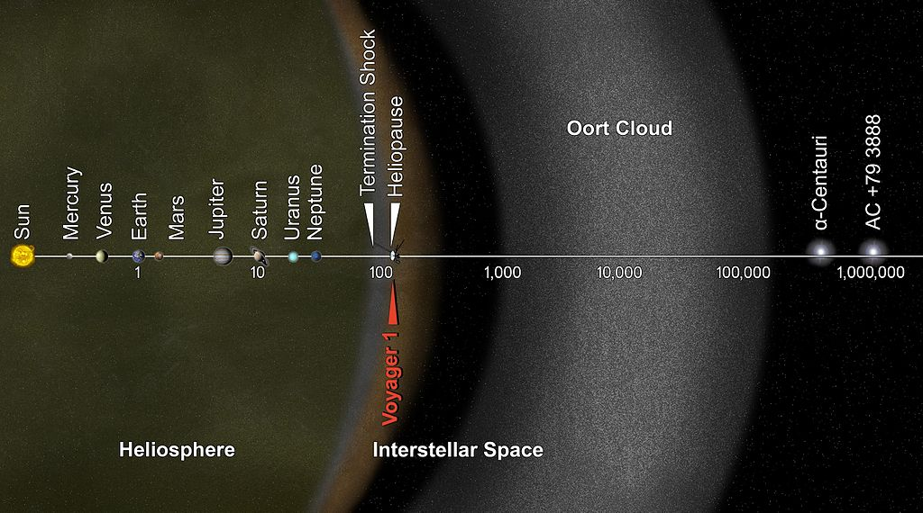
**Add the Kuiper Belt and Oort Cloud to Football Field

- Exoplanets: Worlds Beyond Our Solar System
Excerpts from https://www.space.com/17738-exoplanets.html
Exoplanets are planets beyond our own solar system. Thousands have been discovered in the past two decades, mostly with NASA's Kepler Space Telescope.
These worlds come in a huge variety of sizes and orbits. Some are gigantic planets hugging close to their parent stars; others are icy, some rocky. NASA and other agencies are looking for a special kind of planet: one that's the same size as Earth, orbiting a sun-like star in the habitable zone.
The habitable zone is the range of distances from a star where a planet's temperature allows liquid water oceans, critical for life on Earth. The earliest definition of the zone was based on simple thermal equilibrium, but current calculations of the habitable zone include many other factors, including the greenhouse effect of a planet's atmosphere. This makes the boundaries of a habitable zone "fuzzy."
Astronomers announced in August 2016 that they might have found such a planet orbiting Proxima Centauri. The newfound world, known as Proxima b, is about 1.3 times more massive than Earth, which suggests that the exoplanet is a rocky world, researchers said. The planet is also in the star's habitable zone, just 4.7 million miles (7.5 million kilometers) from its host star. It completes one orbit every 11.2 Earth-days. As a result, it's likely that the exoplanet is tidally locked, meaning it always shows the same face to its host star, just as the moon shows only one face (the near side) to Earth.
Most exoplanets have been discovered by the Kepler Space Telescope, an observatory that began work in 2009 and is expected to finish its mission in 2018, once it runs out of fuel. As of mid-March 2018, Kepler has discovered 2,342 confirmed exoplanets and revealed the existence of perhaps 2,245 others. The total number of planets discovered by all observatories is 3,706.
- Are We the Odd Ones??
http://www.npr.org/blogs/krulwich/2013/05/06/181613582/our-very-normal-solar-system-isn-t-normal-anymore

