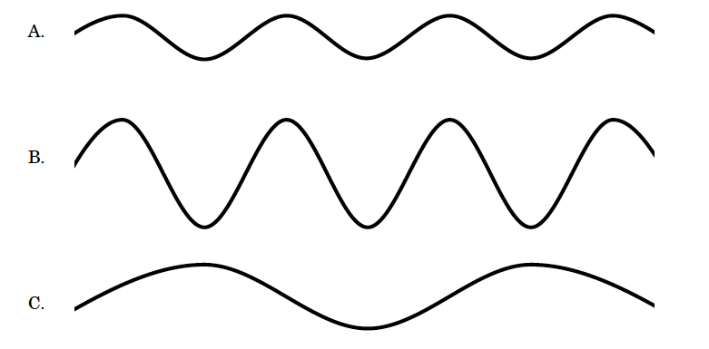
*Note: The time shown is 1 second for each wave.

- Label the following on wave A: wavelength, amplitude, crest and trough.
- Which wave has the largest amplitude?
- Which wave has the highest frequency?

- Which wave has the largest wavelength?

- If you increase the wavelength while the wave speed remains the same, what happens to the frequency? (Hint: does it increase, decrease or stay the same?)
- What happens to the wavelength of a wave when you increase the frequency while the wave speed remains unchanged?
- What needs to happen to a wave in order for the amplitude to increase?
- How are the period and the frequency of a wave related?

Waves Vocabulary – Ch 17.1-17.2
Directions: Define the word and sketch a picture that helps you understand or remember the meaning.
1. Mechanical wave –

2. Medium –

3. Crest –

4. Trough –

5. Transverse wave –

6. Compression –

7. Rarefaction –

8. Longitudinal wave –

9. Period –

10. Frequency (Hertz) –

11. Wavelength –

12. Amplitude –

