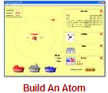Name: _________________________

**Build An Atom PhET Lab** (edited Dec 2010)

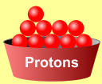**Introduction:** Atoms are the smallest things that retain the properties of matter we can observe.   
<http://phet.colorado.edu/en/simulation/build-an-atom>

Atoms are made of three ***subatomic*** particles; protons, neutrons, and electrons.

* Protons have a mass of ___________ amu and a charge of ___________.
* Neutrons have a mass of ___________ amu and a charge of ___________.
* Electrons have a mass of nearly___________ amu and a charge of ___________.

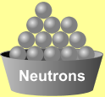In this simulation, you will build atoms, subatomic particle by subatomic particle and observe the effect of adding more of each particle. When the subatomic particles in an atom change, an **ion**, **isotope** or different element will be created.

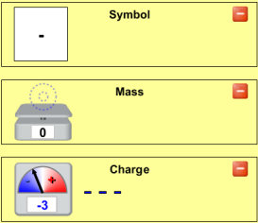**Procedure:** *Play with the Sims 🡪 Chemistry 🡪 Build An Atom* 

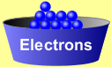Begin by playing with the simulation for a while. Become familiar with the interface. What happens when you add protons, neutrons, or electrons? To start over, click Reset All.

Show the **symbol**, **atomic mass**, and **charge** by clicking on the .

**Analysis Questions**

1. Ions are atoms of the same element with different numbers of __________________.
2. Isotopes are atoms of the same element with different numbers of __________________.
3. Adding or removing protons from an atom does what to the atom? _________________________________.
4. An atom with the same number of protons and electrons has a charge of _________.
5. Adding two electrons to a neutral atom produces an ion with a charge of _________.
6. An atom with six protons and five electrons would have a charge of _________.
7. What atom is created with nine protons, nine neutrons, and nine electrons?
8. Show the full symbol for the above atom in the box at the right
9. What does the upper-left number in the symbol represent? __________________
10. What does the lower-left number in the symbol represent? __________________

**Get your build on!**

|  |  |
| --- | --- |
| **Atom or Ion has** | **What Element is it?** |
| # of protons: 6  # of neutrons: 6 # of electrons: 6 |  |
| # of protons: 7 # of neutrons: 6 # of electrons: 6 |  |
| # of protons: 6 # of neutrons: 7 # of electrons: 7 |  |

**Using all of your rules**, figure out what changes for each of these changes to an atom or ion. Copy this table and make predictions, then test your ideas with the simulation. If you have new ideas, rewrite your rules.

|  |  |
| --- | --- |
| **Make the change:** | **What changes also? Element name, charge, mass?** |
| Add a proton |  |
| Remove a neutron |  |
| Remove an electron |  |
| Add an electron |  |

***Complete the table below******after class*** *as homework/practice.*

|  |  |  |  |  |  |  |  |
| --- | --- | --- | --- | --- | --- | --- | --- |
| Protons | Neutrons | Electrons | Atomic Number | Mass Number | Charge | Element | **Full** Symbol |
| **4** | **4** | **4** | **4** | **8** | **0** | **Be** |  |
| **5** | **5** | **6** | 1. | 2. | 3. | 4. | 5. |
| **8** | **8** | **7** | 6. | 7. | 8. | 9. | 10. |
| 11. | 12. | 13. | **7** | **13** | **-3** | 14. | 15. |
| 16. | 17. | 18. | **9** | **20** | **-1** | 19. | 20. |

**The Game**

If time allows, play the game. It’s great review! You may use the other links as additional resources as well.

**Atom Turotial:** Click on the following link (or type into your browser), and complete the interactive tutorial.

[**Teachers Domain: Atom Tutorial**](http://www.teachersdomain.org/resource/lsps07.sci.phys.matter.theatom/)<http://www.teachersdomain.org/resource/lsps07.sci.phys.matter.theatom/>

**Atom Video Clip:** Click on the following link (or type into your browser), and watch the interactive video clip.

[**BBC: Elements and Atoms Interactive Video Clip**](http://www.bbc.co.uk/schools/ks3bitesize/science/chemical_material_behaviour/atoms_elements/activity.shtml)<http://www.bbc.co.uk/schools/ks3bitesize/science/chemical_material_behaviour/atoms_elements/activity.shtml>