Life Cycle of a Star - Worksheet

A STAR IS BORN – STAGES COMMON TO ALL STARS

All stars start as a **nebula. A nebula** is a large cloud of gas and dust. Gravity can pull some of the gas and dust in a nebula together. The contracting cloud is then called a **protostar.** A protostar is the earliest stage of a star’s life. **A star is born when the gas and dust from a** **nebula become so hot that nuclear fusion starts.** Once a star has “turned on” it is known as **a main sequence star**. When a main sequence star begins to run out of hydrogen fuel, the star becomes a **red giant** or a **red super giant.**

THE DEATH OF A LOW OR MEDIUM MASS STAR

After a low or medium mass or star has become a red giant the outer parts grow bigger and drift into space, forming a cloud of gas called a **planetary nebula**. The blue-white hot core of the star that is left behind cools and becomes a **white dwarf.** The white dwarf eventually runs out of fuel and dies as a **black dwarf.**

THE DEATH OF A HIGH MASS STAR

A dying red super giant star can suddenly explode. The explosion iscalled a **supernova.** After the star explodes, some of the materials from the star are left behind. This material may form a neutron star. **Neutron stars** are the remains of high-mass stars. The most massive stars become **black holes** when they die. After a large mass star explodes, a large amount of mass may remain. The gravity of the mass is so strong that gas is pulled inward, pulling more gas into a smaller and smaller space. Eventually, the gravity becomes so strong that nothing can escape, not even light.

**Question Sheet**

Just like living things and humans, stars have a life cycle, which consists of birth, growth, development, middle age, old age, and death. The life cycle of a star spans over billions of years.

**Section One - Sequencing**

The stages below are not in the right order. Number the stages in the correct order.

__5___ The star begins to run out of fuel and expands into a **red giant** or **red super**

**giant**.

__1___ Stars start out as diffused clouds of gas and dust drifting through space. A single

one of these clouds is called a **nebula**

___6__ What happens next depends on the mass of the star.

__3___ Heat and pressure build in the core of the **protostar** until **nuclear fusion** takes place.

__2___ The force of gravity pulls a nebula together forming clumps called **protostars**.

__4___ Hydrogen atoms are fused together generating an enormous amount of energy igniting the star causing it to shine.

**Section Two - Vocabulary**

Match the word on the left with the definition on the right.

**__c__ black dwarf** **e.** star left at the core of a planetary nebula

**__e__ white dwarf** **g.** a red super giant star explodes

**__b__ nebula c.** what a medium-mass star becomes at the end of its life

**__d__ protostar b.** a large cloud of gas or dust in space

**__g__ supernova** **a.** exerts such a strong gravitational pull that no light escapes

**__f__ neutron star d.** the earliest stage of a star ’s life

**__a__ black hole f.** the remains of a high mass star

**Section Three – Understanding Main Ideas - Low Mass Star**

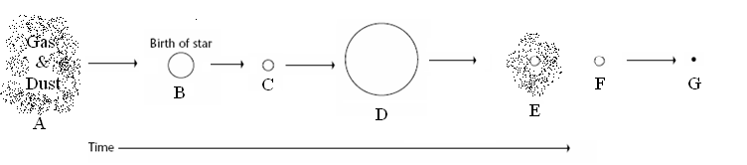

**_D___ 1.** Red giant

**_B___ 2.** Where fusion begins

**_A___ 3.** Nebula

**_G___ 4.** Black dwarf

**_C___ 5.** The stage the sun is in

_**F**___ **6.** White dwarf

_**E**___ **7**. Planetary Nebula

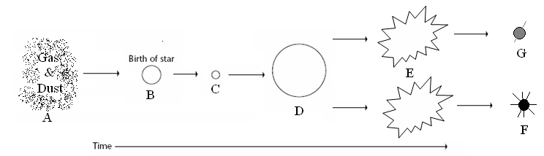**Section Four – Understanding Main Ideas - High Mass Star**

**_F___ 1.** Black Hole

_**E**___ **2**. Supernova

_**B**___ **3**. Protostar

_**A**___ **4**. Gravity causes this to condense into a protostar

_**C**___ **5**. Main sequence star

_**D**___ **6**. When a star begins to run out of fuel and grows larger

_**G**___ **7**. Neutron star

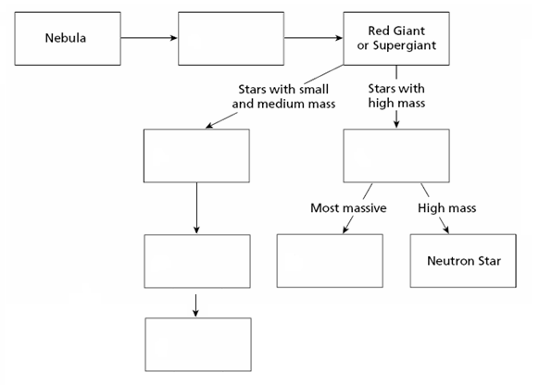**Section Five – Graphic Organizer – Putting it all Together**

Black Dwarf

Black Hole

White Dwarf

Supernova

Planetary Nebula

Main Sequence

**Section Six – Venn Diagram - Compare and Contrast**

High or Very High Mass Star

* Shorter lives
* Fuse heavier elements
* Supernova, Black hole, Neutron star

Both

* Start as nebula
* Protostar and main sequence
* Red Giant /Supergiant
* Fuse H🡪He

Low or Medium Mass Star

* Longer lives
* Only fuse H and maybe He
* Planetary Nebula, White dwarf, Black dwarf

