Honors Physical Science 2018 Name:
Ch 16.1-2 Temperature, Heat, Thermal Energy Period:
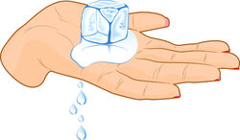
- Define heat. Describe the heat flow based on the picture (hand holding ice).

- We used to think of temperature as how hot or cold something is, but now we are focusing on temperature as related to something else. Explain and include the acronym discussed in class.
- Describe the three temperature scales.
- What is thermal energy? How is this different than mechanical energy?
- Give an example that illustrates how thermal energy depends on mass.
- Give an example that illustrates how thermal energy depends on temperature.
- Draw an example of conduction and explain on a molecular level.
- Why is conduction in gases slower than in liquids and solids?
- Convection, which occurs in fluids, is very important! Sketch and describe three examples of convection currents that occur in natural cycles.
a.

b.

c.
- Describe an example of radiation. Why is radiation unique?

