Graph Matching Lab Name __________________ Pd _____

One of the most effective methods of describing motion is to plot graphs of position and velocity *vs*. time. From such a graphical representation, it is possible to determine in what direction an object is going, how fast it is moving, how far it traveled, and whether it is speeding up or slowing down. In this experiment, you will use a Motion Sensor to determine this information by plotting a real time graph of *your* motion as you move across the classroom.

The Motion Sensor measures the time it takes for a high frequency sound pulse to travel from the detector to an object and back. Using this round-trip time and the speed of sound, the interface can determine the distance to the object; that is, its position. It can then use the change in position to calculate the object’s velocity and acceleration. All of this information can be displayed in a graph. A qualitative analysis of the graphs of your motion will help you understand the concepts of kinematics.



objectives

* Analyze the motion of a student walking across the room.
* Predict, sketch, and test distance *vs*. time kinematics graphs.
* Predict, sketch, and test velocity *vs*. time kinematics graphs.

Materials

|  |  |
| --- | --- |
| Labquest mini interface | Vernier Motion Sensor |
| Chromebook | meter stick |
| Graphical Analysis App | masking tape |

Preliminary questions

1. Sketch what you think the **position *vs*. time graph** for each of the following situations will look like. Use a coordinate system with the origin at far left and positive distances increasing to the right. I have created the blank graphs to help you get started.

1. An object at rest
2. An object moving in the positive direction with a constant speed
3. An object moving in the negative direction with a constant speed
4. An object that is accelerating in the positive direction, starting from rest

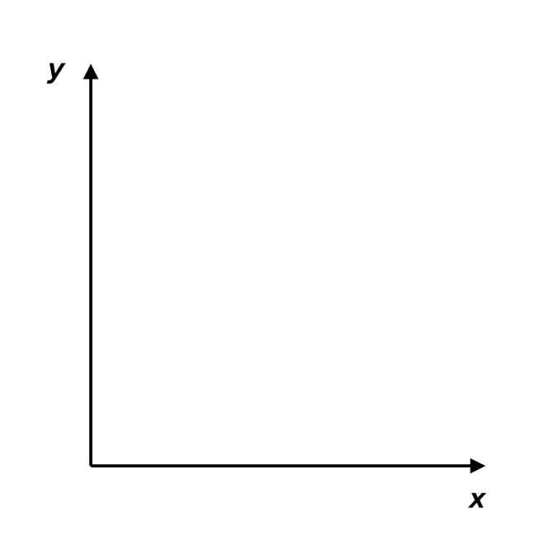2. Sketch what you think the **velocity *vs*. time graph** will look like for each of the situations described above.

c. Moving in the negative direction, constant speed

d. Accelerating in the positive direction, starting from rest

a. An object at rest

b. Moving in the positive direction, constant speed

c. Moving in the negative direction, constant speed

b. Moving in the positive direction, constant speed

d. Accelerating in the positive direction, starting from rest

a. An object at rest

c. Negative direction, constant speed

b. Positive direction, constant speed

Procedure

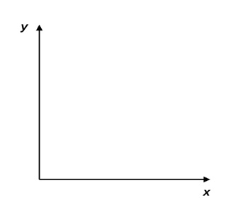Part l Preliminary Experiments

1. Place the Motion Sensor so that it points toward an open space roughly 4 m long.

2. Record a position vs. time graph of your motion when you walk away from the sensor with constant velocity.

3. Sketch what you think the position *vs.* time graph will look like if you walk faster. Check your prediction with the Motion Sensor.

4. Try to match the shape of the distance *vs*. time graphs that you sketched in the Preliminary Questions section by walking in front of the Motion Sensor.

Part Il Distance *vs*. Time Graph Matching

5. Under the “Graph Tools” button, add a graph match for distance vs. time and attempt to match the motion of at least three graphs.

6. Answer the Analysis questions for Part II before proceeding to Part III.

Part IIl Velocity vs. Time Graph Matching

7. Under the “Graph Tools” button, add a graph match for velocity vs. time and attempt to match the motion of at least three graphs.

Analysis

Part II Position *vs*. Time Graph Matching

1. Describe how you walked for each of the graphs that you matched.

1. Explain the significance of the slope of a distance *vs*. time graph. Include a discussion of positive and negative slope.
2. What type of motion is occurring when the slope of a distance *vs*. time graph is zero?
3. What type of motion is occurring when the slope of a distance *vs*. time graph is constant?
4. What type of motion is occurring when the slope of a distance *vs*. time graph is changing? Test your answer to this question using the Motion Detector.
5. Return to the procedure and complete Part III.

Part III Velocity *vs*. Time Graph Matching

1. Describe how you walked for each of the graphs that you matched.

8. What type of motion is occurring when the slope of a velocity *vs*. time graph is zero?

9. What type of motion is occurring when the slope of a velocity *vs*. time graph is not zero? Test your answer using the Motion Detector.

Extensions

1. Create a graph-matching challenge. Sketch a distance *vs*. time graph on a piece of paper and challenge another student in the class to match your graph. Have the other student challenge you in the same way.
2. Create a velocity *vs*. time challenge in a similar manner.