OBJECTIVE 2: Examine the conservation and transformation of energy within systems.
Link 1:
https://www.texasgateway.org/resource/energy-transformation

Types of Energy
Click on the icons to briefly review the different types of energy.

Energy Transformations
- Describe the energy transformations when a flashlight is turned on.
- Complete the Energy Transformations Practice. Insert screenshot of completed task or show your teacher so they can sign off on it.

Link 2: Energy Forms and Changes PhET https://phet.colorado.edu/sims/html/energy-forms-and-changes/latest/energy-forms-and-changes_en.html

Click on the Systems tab. Use the PhET to explore different energy transformations. Then, identify the transformations taking place in the following images.

 | Image | Energy transformation explanation
1 | 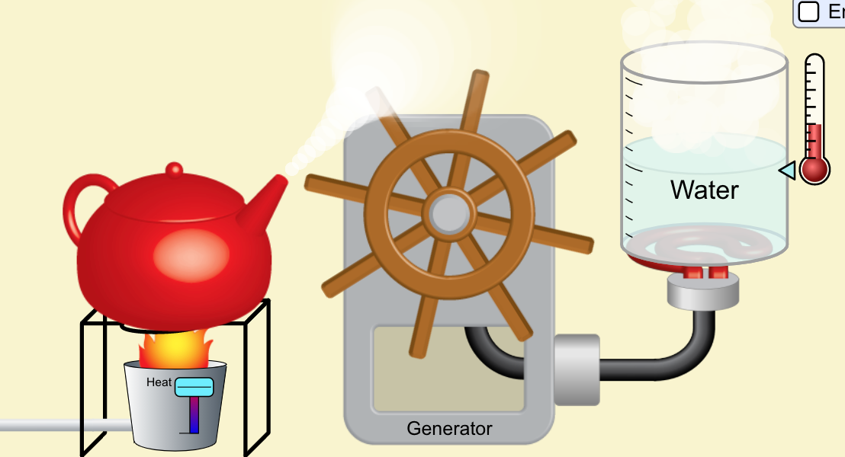
2 | 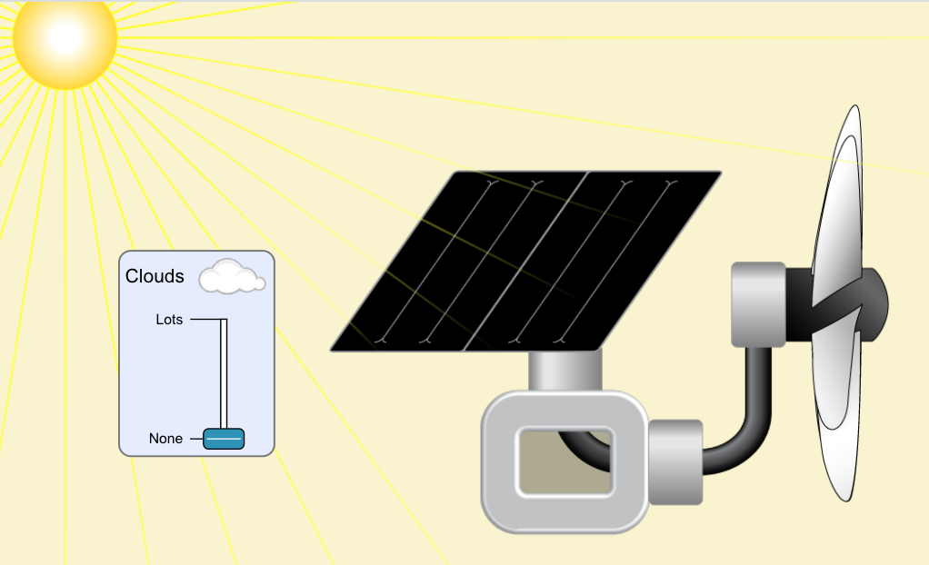
3 | 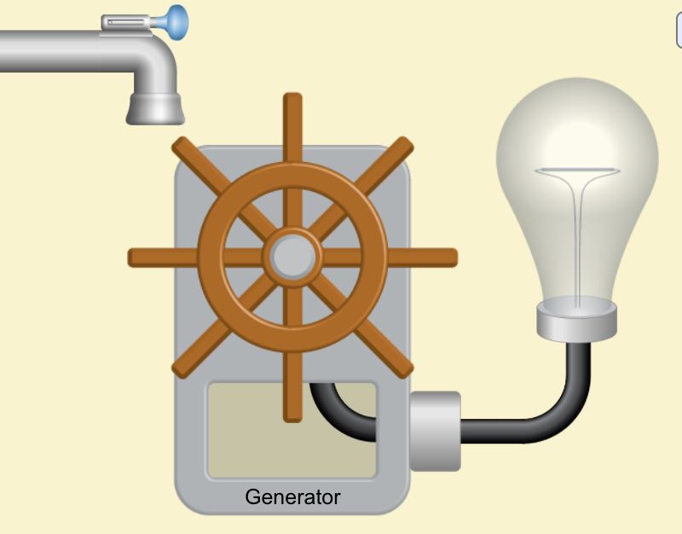
4 | 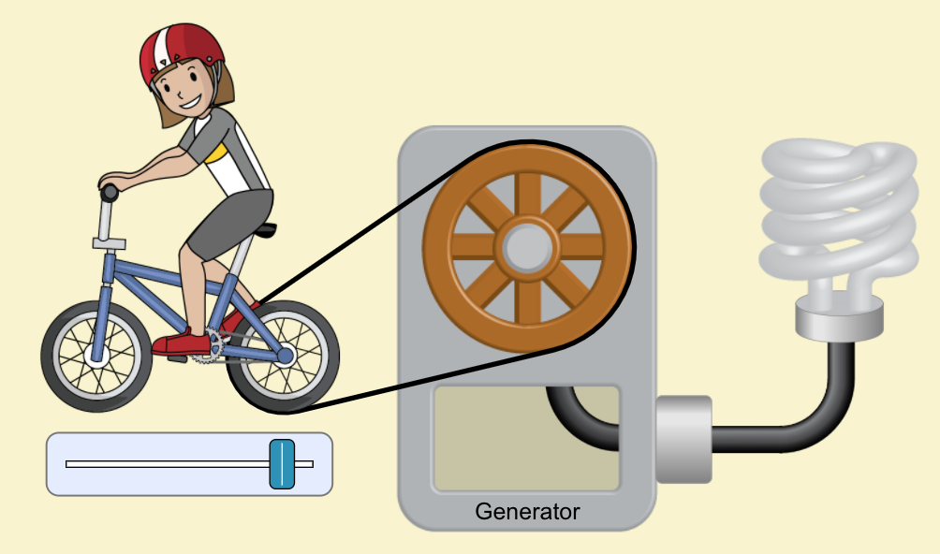
5. Describe the difference between the 2 lightbulbs in terms of energy production.
Link 3: EduMedia - E3.1 Energy Transformations
https://www.edumedia-sciences.com/en/curriculum/2133-e31-describe-and-compare-various-types-of-energy-and-energy-transformations-eg-transformations-related-to-kinetic-sound-electric-chemical-potential-mechanical-nuclear-and-thermal-energy
Click on the following boxes and explain the energy transformations.:

- Solar Energy:
- Power Plant:
- Hydroelectric Plant:

Link 4: Lincoln’s Energy Resources
https://www.les.com/company/generation-resources

Where does the energy that WE use in Lincoln come from? Investigate on LES’s website and briefly summarize below.
Reflection Questions:
- Outline the energy transformations that occur within your cell phone every day. Be specific!

- Outline the energy transformations that occur within your chromebook every day. Be specific!

- Come up with your own example of an energy transformation. Explain.
What happens if the sequence isn't completed?

Link 5: CK 12 10 point Check for Understanding
https://www.ck12.org/assessment/ui/?test/view/practice/physics/energy-conversion-Practice&ep=https://www.ck12.org/physics/energy-conversion/?referrer=concept_details

Click the link and take the 10 question quiz. Insert screenshot of completed task or show your teacher so they can sign off on it.

