EFFORT RUBRIC | Minimal Effort  (1 point) | Moderate Effort  (3 points) | High Effort  (5 points)
Organization & planning | - Rarely sets short-term or long-term goals or no/little effort in assessing progress | - Sets short-term and long term goals but does not assess progress. | - Sets short-term and long-term goals & routinely assesses progress
 | - Doesn’t use a planner to record course tasks. | - Uses a planner to record SOME course tasks and/or does not review it often/ever. | - Uses a planner to record ALL course tasks¹ and reviews it often
 | - Spends little or no time on learning course tasks | - Doesn’t manage time effectively and/or partially completes course tasks | - Manages time effectively so all course tasks get completed as required²
 | - Maintains a notebook which contains little to no course materials | - Maintains a notebook which contains some course materials and/or is disorganized | - Maintains an organized notebook which contains ALL relevant course materials
Engagement/participation | - Is actively disengaged during class and course tasks. | - Is distracted or inattentive during parts of class or course tasks. | - Is attentive during class and course tasks ALL of the time.
 | - Rarely participate or is disruptive during cooperative activities | - Participates partially in cooperative activities and/or isn’t constructive. | - Contributes constructively³ to cooperative activities.
 | - Rarely uses personal strategies during learning cycle | - Attempts to use personal strategies during the learning cycle | - Effectively uses personal learning strategies⁴ during the learning cycle⁵
 | - Rarely asks questions to monitor learning | - Is inconsistent with asking questions to monitor learning | - Asks questions of teachers, peers or self to monitor learning⁶
 | - Attends class LESS than 90% of the time and/or is frequently tardy | - Attends class MORE than 90% of the time and/or sometimes tardy | - Attends class at or near 100% of the time and is seldom tardy
Formative practice work | - Completes less than 60% of the formative work/practice and much of which isn’t completed in a timely fashion | - Completes more than 60%, but less than 100%, of the formative work/practice and/or is not completed in a timely fashion | - Completes 100% of formative work in a timely manner
 | - Rarely use formative work to identify or reinforce learning objectives | - Is inconsistent with using formative work to identify and reinforce learning objectives | - Uses formative work to identify and reinforce learning objectives
Reflection | - Rarely uses learning objectives to assess understanding after learning cycle(s) | - Identifies learning objectives but doesn’t use them to assess understanding after learning cycle(s) | - Reviews learning objectives to assess understanding after learning cycle(s)
 | - Has a Fixed Mindset when reflecting on formative and summative work | - Has a Mixed Mindset when reflecting on formative and summative work | - Has a Growth Mindset⁷ when reflecting on formative and summative work
 | - Rarely reviews personal work to assess learning and understanding. | - Sometimes reviews personal work and/or doesn’t assess learning and understanding | - Always reviews personal work (notes/ practices) to assess learning/ understanding
 | - Rarely uses support systems when needed | - Sometimes uses support systems when needed | - Always uses support systems⁸ when needed
 | - Rarely acknowledges feedback and doesn’t apply strategies for making improvements | - Acknowledges feedback but doesn’t apply strategies for making improvements | - Acknowledges feedback and applies strategies for making improvements
 |  |  | Total Score

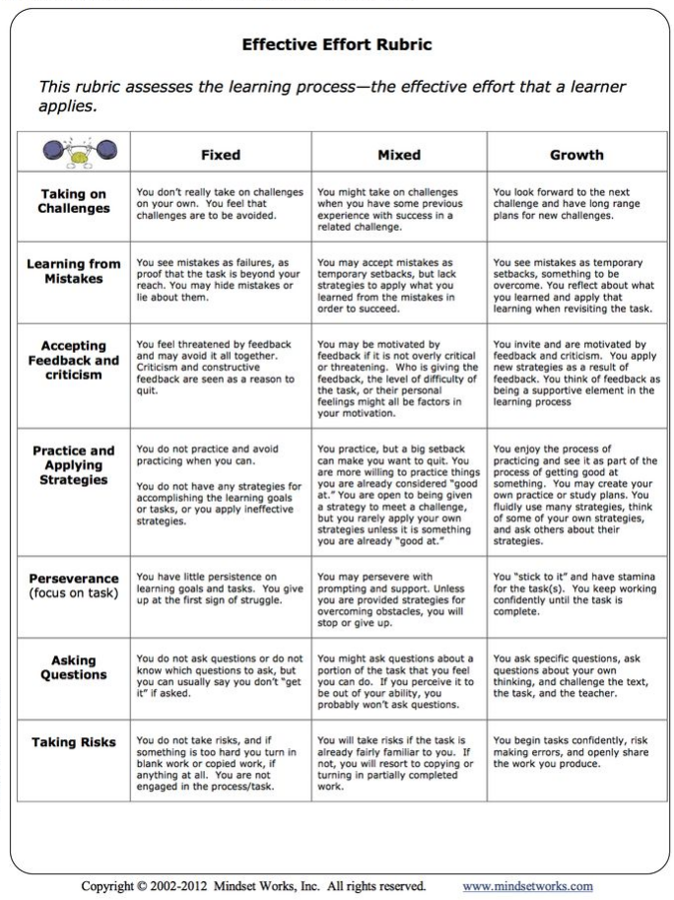Conversation notes (footnotes from rubric):
1. Course task- any assignment, assessment or class requirement that requires attentiveness by the student, either inside or outside of class. Examples are tests, quizzes, homework, formative practice, projects/labs, cooperative activities or class discussions.
2. Good time management means balancing coursework and extra-curricular/life events
3. Constructive contribution means students are positively interdependent and individually accountable. Will be discussed with students in the classroom.
4. Personal learning strategies --examples: summarization, outlining, reading strategies, note-taking strategies, flipped-curriculum, discussion strategies (tech-based), collaboration strategies
5. Learning cycle is defined as the time frame from introduction of an objective, engagement in lesson, use formative practice, to the feedback/reflection process.
6. “Monitor”--definition
7. See table on following page (effective effort rubric)

8. Support systems- teachers (before/after school & lunch), peers (such as study groups), tutors, ARC, answer keys, videos, study groups, LINKZONE, etc.

According to a recent ACT report, the strongest predictor of academic success, aside from prior academic achievement, is academic discipline, which is defined as the “skill component of motivation” and is exhibited in the amount and quality of effort students devote to schoolwork and the degree to which students engage in learning new things

When students master a topic or skill, this can enhance their sense of self-efficacy. This does not mean, however, that curricula should be “dumbed down” in order to ensure mastery (research shows that students must have access to rigorous curricula if they are to be academically successful), but it does have implications for the ways in which challenging material is taught. For example, instructional activities may need to include breaking down complex problems into manageable steps; setting specific goals; and providing regular feedback.

