Effort Rubric Name: _____________________________

Directions: Circle the descriptor that fits your behavior. Add your scores and record at the bottom.
Organization and Planning
1. I routinely set short-term and long-term goals and regularly assess my progress. | 5. Always | 4. Often | 3. Sometimes | 2. Rarely | 1. Never
2. I use a planner to record all course tasks¹ and I review it often. | 5. Always | 4. Often | 3. Sometimes | 2. Rarely | 1. Never
3. I manage my time effectively so all course tasks get completed as required². | 5. Always | 4. Often | 3. Sometimes | 2. Rarely | 1. Never
4. I maintain an organized binder which contains ALL relevant course materials. | 5. Always | 4. Often | 3. Sometimes | 2. Rarely | 1. Never

Engagement/Participation
5. I am attentive during class and course tasks throughout the entire class period. | 5. Always | 4. Often | 3. Sometimes | 2. Rarely | 1. Never
6. I contribute constructively³ to cooperative activities. | 5. Always | 4. Often | 3. Sometimes | 2. Rarely | 1. Never
7. I use personal learning strategies⁴ effectively throughout the learning cycle⁵. | 5. Always | 4. Often | 3. Sometimes | 2. Rarely | 1. Never
8. I ask questions of teachers, peers and/or myself to monitor⁶ my learning. | 5. Always | 4. Often | 3. Sometimes | 2. Rarely | 1. Never
9. I attend class every day of the week and I am not tardy. | 5. Always | 4. Often | 3. Sometimes | 2. Rarely | 1. Never

Formative Practice Work
10. I complete 100% of my formative work in a timely manner. | 5. Always | 4. Often | 3. Sometimes | 2. Rarely | 1. Never
11. I relate my formative work back to the learning objectives. | 5. Always | 4. Often | 3. Sometimes | 2. Rarely | 1. Never

Reflection
12. I review the learning objectives to assess my understanding after the learning cycle(s). | 5. Always | 4. Often | 3. Sometimes | 2. Rarely | 1. Never
13. I have a Growth Mindset⁷ when reflecting on formative and summative work. | 5. Always | 4. Often | 3. Sometimes | 2. Rarely | 1. Never
14. I always review my personal work (notes/practices/quizzes) to assess my learning/ understanding. | 5. Always | 4. Often | 3. Sometimes | 2. Rarely | 1. Never
15. I advocate for myself and use support systems⁸ when I need them. | 5. Always | 4. Often | 3. Sometimes | 2. Rarely | 1. Never
16. I use the feedback I receive to develop and apply strategies to help me improve. | 5. Always | 4. Often | 3. Sometimes | 2. Rarely | 1. Never

Score: ______ /80

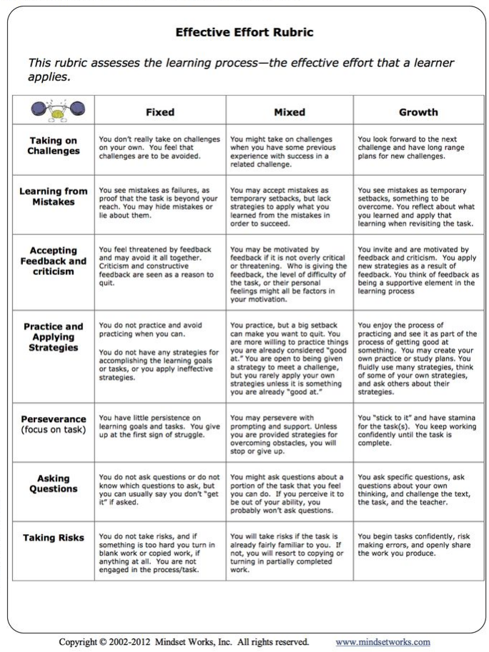
1. Course task- any assignment, assessment or class requirement that requires attentiveness by the student, either inside or outside of class. Examples are tests, quizzes, homework, formative practice, projects/labs, cooperative activities or class discussions.
2. Good time management means balancing coursework and extra-curricular/life events
3. Constructive contribution means students are positively interdependent and individually accountable. Will be discussed with students in the classroom.
4. Personal learning strategies --examples: summarization, outlining, reading strategies, note-taking strategies, flipped-curriculum, discussion strategies (tech-based), collaboration strategies
5. Learning cycle is defined as the time frame from introduction of an objective, engagement in lesson, use formative practice, to the feedback/reflection process.
6. “Monitor”—making sure you understand concepts and how they connect to previous learning.
7. See table at right (effective effort rubric)
8. Support systems- teachers (before/after school & lunch), peers (such as study groups), tutors, ARC, answer keys, videos, study groups, LINKZONE, etc.

