**Earth History Study Guide**

Define Uniformitarianism. Who said it? Examples?

What is the difference between relative age and absolute age?

**Law of Superposition:** (sketch)

**Law of Original Horizontality:** (define)

Below are the types of fossils we discussed. Describe each.

Amber:

Carbon Film:

Trace Fossils:

Gastroliths:

Coprolites:

Casts:

Molds:

Petrified:

What is the **Principle of Fossil Succession**?

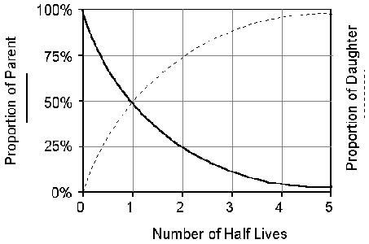

What does the **Theory of Evolution** say?

Label the layers from oldest to youngest. Put a **C** next to any examples of cross-cutting.

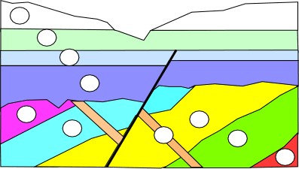

What is an inclusion?

What is an unconformity? 3 types?

How can you turn into a fossil? (2 steps)

What are **index fossils**?

What can fossils tell us about climate?

What is an isotope? Which one is stable? Unstable?

What is a half-life?

Label the parent and the daughter elements.

List 2 radioactive elements, their daughter elements (what they turn into) and how long their half-life is.

1. element:
   1. daughter element:
   2. half-life:
2. element:
   1. daughter element:
   2. half-life:

Nickel-63 has a half-life of 90 years. How much nickel-63 would remain in a 20 g sample at the end of 180 years?

A rock sample originally had 10,000g of C-14. Now it has 2,500 g of C-14. How many years have passed?

Fill in the names of the eras and  
match the picture to the right   
era.

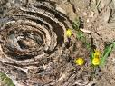

Stromatolites (prokaryotic, single-celled organisms)

Why can’t you use radioactive dating on sedimentary rocks?

Put in order from biggest to smallest:  
_______ Eon

_______ Epoch

_______ Era

_______ Period

What are the 3 main eras? How many years ago did each begin? What does each of the names mean?

*Label each with the appropriate Era*

________________________ Age of reptiles

________________________ Age of mammals

________________________ Fossils are rare

________________________ The longest era

*Eras are separated by mass _________________.

How old is the Earth?

What is the **Geologic column**?

Periods are defined by specific fossils and usually named by: