Dimensional Analysis Breakdown 2022 Name _________________________________ _
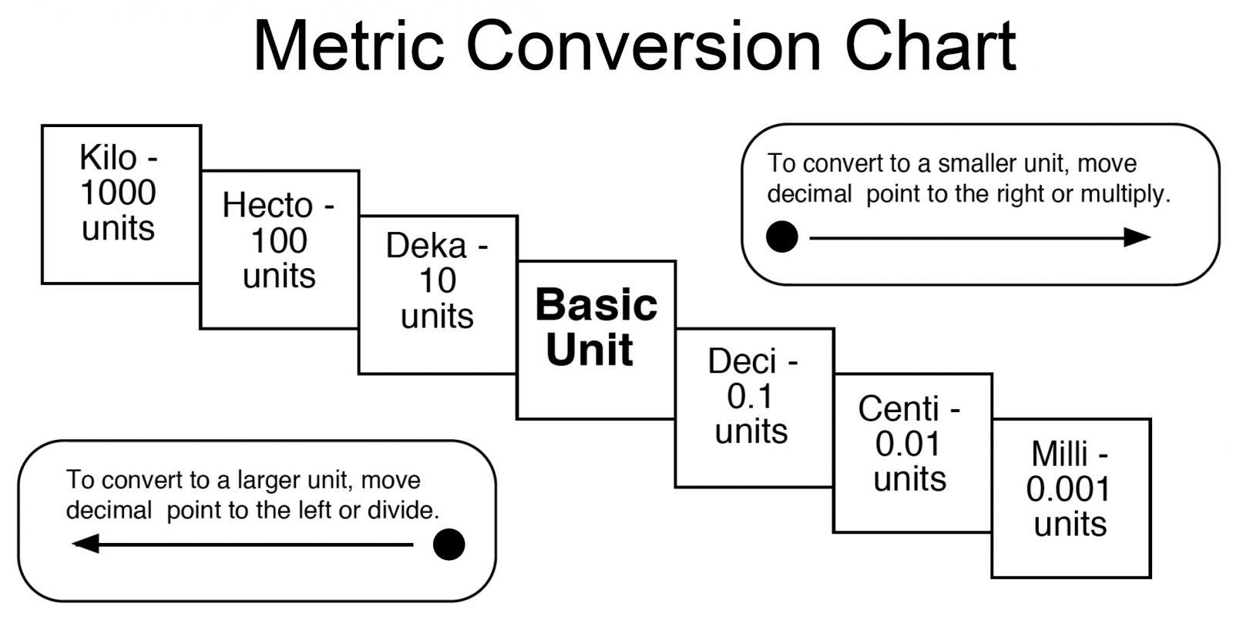
1) 2000 mg = __________ g
2) 104 km = __________ m
3) 480 cm = __________ m

4) 5.6 kg = __________ g
5) 2500 m = __________ km
6) 120 mg = __________ g

Steps to Solving Dimensional Analysis Problems:
1. Look at what you started with. EX: How many inches are in 6 meters?
2. Identify the desired units. EX: How many inches are in 6 meters?
3. Find the conversion. EX: 2.54 cm = 1 inch
4. Decide which conversion factor will allow you to cancel the appropriate units. (See # 8)
5. Multiply and divide as needed. Check sig figs!

8) Circle the conversion factor you would choose to solve the following problems:
- How many inches are in 6 meters? 1 meter OR 39.4 inches
39.4 inches 1 meter
- How many liters are in 10 U.S. gallons? 3.79 liters OR 1 gallon
1 gallon 3.79 liters
- 100 kilometers is equal to how many miles? 1 kilometer OR 0.624 miles
0.624 miles 1 kilometer
9) The distance between Happyville and Giggleland is 60 miles. How far is this in kilometers?
1 mile = 1.609 km
Show Work: | Final Answer:
10) A cookie recipe calls for 1 pound of butter. How many grams of butter would be needed for 3 batches? 1 kg = 2.2 lb
Show Work: | Final Answer:
11) A recipe uses 1.0 cup of flour for every 3 eggs. The eggs are increased to 5. How much flour should be used?
Show Work: | Final Answer:
12) How many tablespoons are there in 4 quarts of ice cream if there are 2 tablespoons to an ounce and 32 ounces to a quart?
Show Work: | Final Answer:

13) If there are 100.0 mg of Vitamin C per pill and 500 pills to a bottle, how many mg of Vit C are there in 3 cases of bottles (12 bottles to a case)?
Show Work: | Final Answer:

14) There are 14 oinks per pig and 18 grunts per pig. Each grunt requires 7 oops. Every oops need 2 umps. There are 9 slurps per ump. How many slurps are there per oink?
Show Work: | Final Answer:

15) How many miles will 300.0 gallons of gasoline take a car that gets 20.0 miles to the gallon?
Show Work: | Final Answer:

16) The space shuttle travels at 17,500 miles/hour. How many meters/second is this? There are 39.37 inches in a meter, and 5280 feet/mile.
Show Work: | Final Answer:

17) In the above question, how many miles per second is this?
Show Work: | Final Answer:

18) Denver is 500.0 miles from Lincoln. How many seconds does it take for the shuttle to travel to Denver? (See question # 16)
Show Work: | Final Answer:

