Name _________________________________ Period ____________ Date ____________

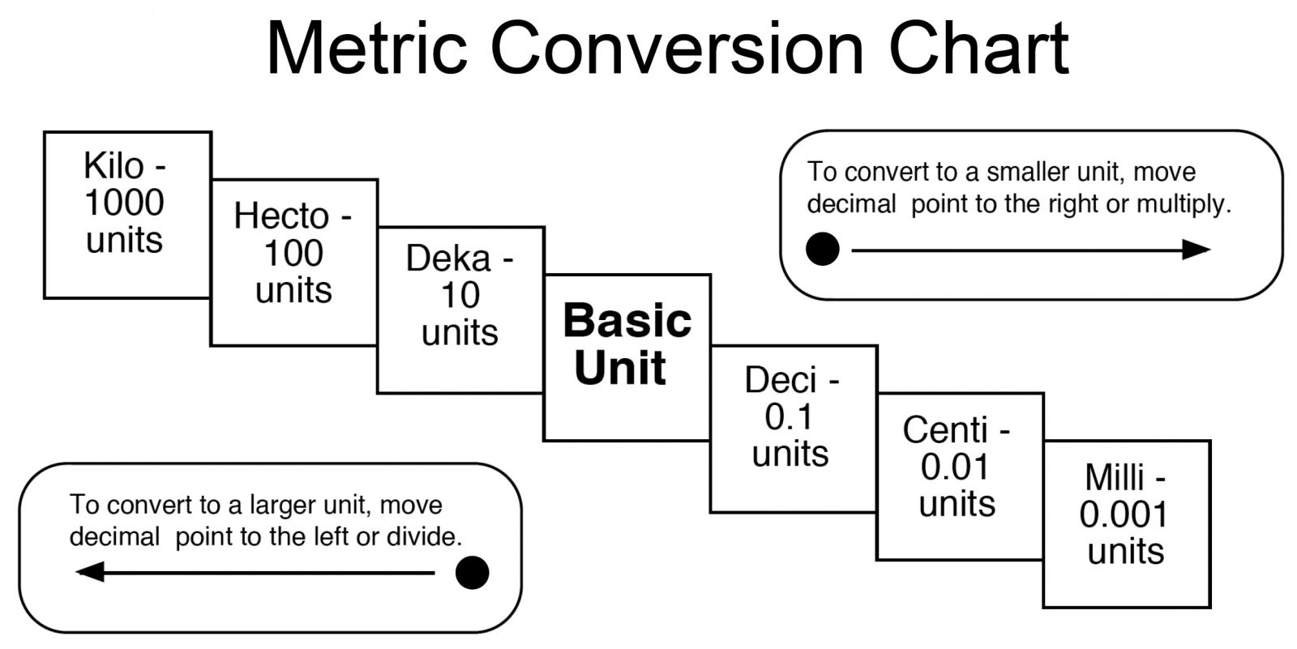

1) 2000 mg = __________ g 2) 104 km = __________ m 3) 480 cm = __________ m

4) 5.6 kg = __________ g 5) 2500 m = __________ km 6) 120 mg = __________ g

7) Order the following steps:

_____ Find the conversion. EX: 2.54 cm = 1 inch

_____ Look at what you started with. EX: How many inches are in 6 meters?
_____ Multiply and divide as needed.
_____ Identify the desired units. EX: How many inches are in 6 meters?
_____ Decide which conversion factor will allow you to cancel the appropriate units. (See # 8)

8) Circle the conversion factor you would choose to solve the following problems:

- How many inches are in 6 meters? 1 meter OR 39.4 inches
39.4 inches 1 meter
- How many liters are in 10 U.S. gallons? 3.79 liters OR 1 gallon
1 gallon 3.79 liters
- 100 kilometers is equal to how many miles? 1 kilometer OR 0.624 miles
0.624 miles 1 kilometer

9) The distance between Happyville and Giggleland is 60 miles. How far is this in kilometers?
1 mile = 1.609 km

10) A cookie recipe calls for 1 pound of butter. How many grams of butter would be needed for 3 batches? 1 kg = 2.2 lb

11) A recipe uses 1 cup of flour for every 3 eggs. The eggs are increased to 5. How much flour should be used?

12) How many tablespoons are there in 4 quarts of ice cream if there are 2 tablespoons to an ounce and 32 ounces to a quart?

13) If there are 100 mg of Vitamin C per pill and 500 pills to a bottle, how many mg of Vit C are there in 3 cases of bottles (12 bottles to a case)?

14) There are 14 oinks per pig and 18 grunts per pig. Each grunt requires 7 oops. Every oops need 2 umps. There are 9 slurps per ump. How many slurps are there per oink?

15) How many miles will 300 gallons of gasoline take a car that gets 20 miles to the gallon?

16) The space shuttle travels at 17,500 miles/hour. How many meters/second is this? There are 39.37 inches in a meter, and 5280 feet/mile.

17) In the above question, how many miles per second is this?

18) Denver is 500 miles from Lincoln. How many seconds does it take for the shuttle to travel to Denver? (See question # 16)

