Class Notes Unit 7 Objectives 5 & 6

Objective 6: Categorize substances as elements, compounds, mixtures and pure substances.
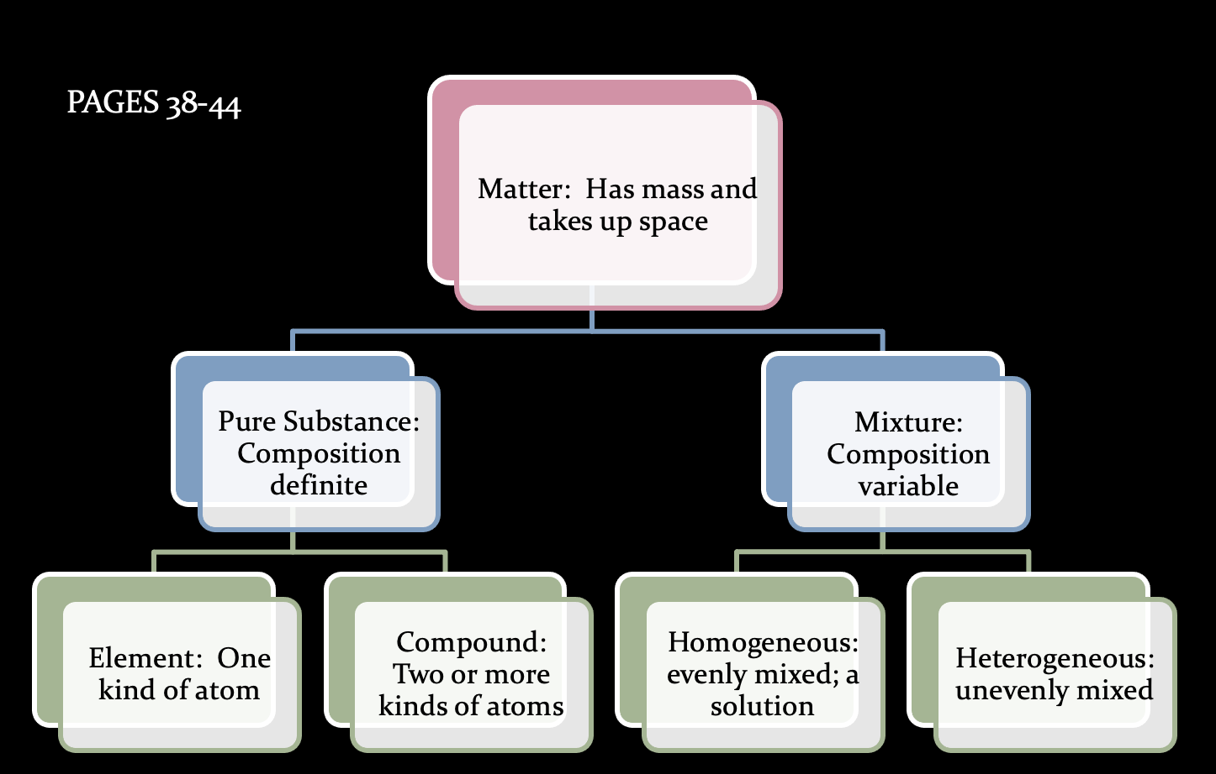
Elements: Calcium, Oxygen, Chlorine
- Broken down by nuclear means
Compounds: NaCl, H₂0
- Broken down by chemical means
Heterogeneous: pond water, chili
(Suspension: parts settle over time)
- Broken down by physical means
Homogeneous: salt water, tap water, air, Kool-aid (Solution: well-mixed mixture)
- Broken down by physical means

Objective 5: Distinguish between chemical and physical properties of matter.

Physical Properties
- Definition: any characteristic of a material that can be observed or measured without changing the composition of the substances in the material
- EX: viscosity, conductivity, malleability, hardness, melting point, boiling point, density, volume, shape, color, mass, taste, opacity, salinity, pressure, luster, elasticity
- Used to identify a material, choose a material for a specific purpose, or separate the substances in a mixture.
  - Separating mixtures: picking pieces out, magnet, sift, filtration, distillation, density
Physical Change
- Definition: Occurs when some of the properties of a material change, but the substances in the material remains the same
- EX: phase changes, crumple/tear/fold paper, cut/braid hair
- Some are reversible, while some are not.

Chemical Properties
- Definition: any ability to produce a change in the composition of matter (one substance turns into a new substance)
- EX: flammability (can burn in the presence of oxygen) *important for fuel
- EX: reactivity (describes how readily a substance combines chemically with other substances) *oxygen is highly reactive, while nitrogen is not.
Chemical Change
- Definition: Occurs when a substance reacts and forms one or more new substances
- EX: baking a cake, leaves changing color, digesting food
- Evidence for chemical changes: change in color, production of gas, formation of precipitate

