Class Notes Unit 7 Objectives 1, 3, 2, 4 (out of order on purpose)

Objective 1: Describe particle arrangement and particle motion in the four states of matter.

 | shape | volume | particles | KE | IMA’s
solid | definite | definite | Packed tight, vibrate in place | low | strong
liquid | container | definite | Flow passed each other | middle | middle
gas | container | container | Fast, straight, spread out | high | low/none
plasma | container | container | Ionized gases | Very high | none

5th state of matter: Bose-Einstein condensate → groups of atoms behave like a single particle at extremely low temps (-273*C)

Kinetic Molecular Theory: all matter is composed tiny particles and those particles are in constant motion

Objective 3: Describe the relationship between temperature and state of matter using a heating curve.

Key Terms:
Phase change: reversible physical change when a substance changes from one state of matter to another

Endothermic: system absorbs E | Exothermic: system releases E
Melting: Solid → Liquid | Freezing: Liquid → Solid
Vaporization: Liquid → Gas  - Boiling: requires a certain temp, occurs throughout the sample  - Evaporation: can occur below the BP, takes place at the surface | Condensing: Gas → Liquid
Sublimation: Solid → Gas  EX: Dry ice | Deposition: Gas → Solid  EX: Frost

Heating Curve:
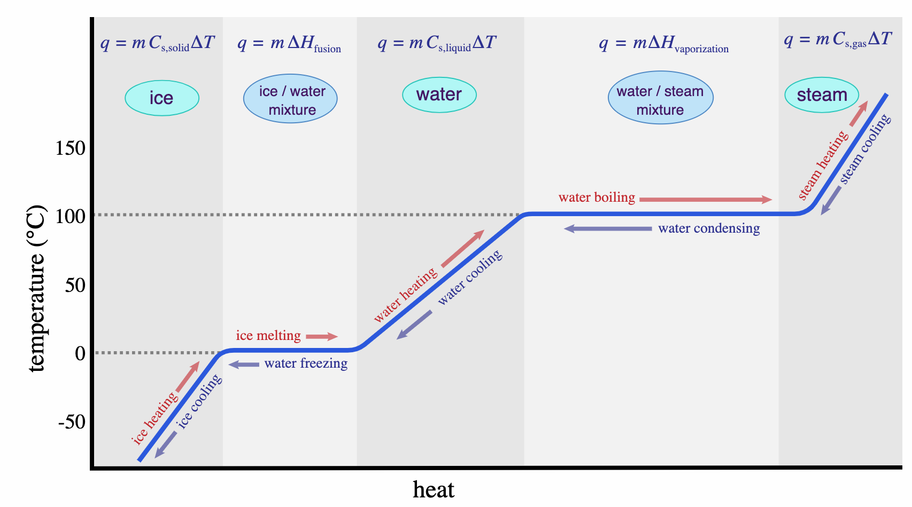

Heat Curve Explained:
Temperatures increase when solid, liquid, or gas, because the energy added goes to speeding up the particles.
Temperatures do NOT change during a phase change, because the E is going to weaken or overcome the IMA’s.

Specific heat: the amount of heat energy needed to raise 1 gram of a substance by 1*C. Be sure your units for specific heat match the units in the problem. J/g*C or J/kg*C
The equation is Q = mC(T_{f} - T_{i}) where
Q is the heat energy (joules), m is the mass of the sample (grams or kilograms*), C is the specific heat of the substance (J/g*C), and T_{f} - T_{i} is the change in temperature (*C)
The higher the specific heat, the more energy is required to cause a change in temperature.

*This equation is used when the state of matter does not change.
Latent heat: the “hidden” heat when a substance absorbs or releases heat without producing a change in the temperature of the substance (ex: during a phase change). Be sure your units for specific heat match the units in the problem.
The equation for Latent Heat of Fusion is Q = mL_{f} where
Q is the heat energy (joules), m is the mass of the sample (grams or kilograms*), L_{f} is the latent heat of fusion for the substance (J/g)

*This equation is used when the sample is changing from a solid to a liquid.
The equation for Latent Heat of Vaporization is Q = mL_{v} where
Q is the heat energy (joules), m is the mass of the sample (grams or kilograms*), L_{v} is the latent heat of vaporization for the substance (J/g)
*This equation is used when the sample is changing from a liquid to a gas.

Objective 4: Demonstrate the relationships between pressure, moles, volume, and temperature of a confined gas.

Gas Variables:
- Pressure: the result of a force distributed over an area
P = F/A where F is measured in Newtons, A is measured in m²
1 atm = 1013.25 millibars = 101.3 kPa = 14.7 psi = 760 mm Hg
- Temperature – the speed of the gas molecules. Measured in Kelvin (K).
- Volume – amount of space of the container. Measured in Liters (L).
- Moles (n) - deals with # particles

 | Boyle’s Law  (Vice Pres) | Gay-Lussac’s Law  (Toilet Paper) | Charles’s Law  (watched direct TV)
Equation | P₁V₁ = P₂V₂ | P₁ = P₂  T₁ T₂ | V₁ = V₂  T₁ T₂
Relationship | Inverse | Direct | Direct
Units | Volume: cm³, m³, L  Pressure: atm, kPa, mm Hg | Temperature: Kelvin  *C + 273 = K  Pressure: atm, kPa, mm Hg | Temperature: Kelvin  *C + 273 = K  Volume: cm³, m³, L

Combined Gas Law: P₁V₁ = P₂V₂
T₁ T₂

(This law combines the three laws above. It can be helpful to memorize just one equation rather than three separate ones. Use when the mass of the gas is fixed.)

Converting Celsius to Kelvin: Add 273 and round in the middle of the problem. It can change your sig figs. EX:
25*C → 298K 25.0*C → 298.0K 100*C → 400K 100.*C → 373K 100.0*C → 373.0K

Boyle’s Law Examples:
Decrease V → Increase P EX: popping a balloon, deep sea divers if they don’t have pressure regulating suits…ouch, bike pump
Increase V → Decrease P EX: deep sea fish die when they reach surface (P decreases, so V increases)

Gay-Lussac’s Law Example:
Increase T → Increase P EX: car tires on a long car trip
Decrease T → Decrease P EX: car tires in the cold temps

Charles’s Law Example:
Increase T → Increase V EX: heat confined gas and it will explode, hot air balloon, bake bread
Decrease T → Decrease V EX: leave a balloon or ball in the cold car and it will get flat

Ideal Gas Law: PV = nRT *Includes amount of gas

where n is moles and R is a constant: 8.314 (L*kPa)/(mol*K) or 0.0821 (L*atm)/(mol*K)

A mole is defined as 6.02214076 × 10²³ of some chemical unit, be it atoms, molecules, ions, or others. The mole is a convenient unit to use because of the great number of atoms, molecules, or others in any substance.

Objective 2: Illustrate the effect of pressure and temperature on a state of matter using a phase diagram

Pressure: the result of a force distributed over an area
P = F/A where F is measured in Newtons, A is measured in m²
Units of pressure: 1 atm = 101.3 kpa = 760 mm Hg

Phase diagram: graphical way to depict the effects of pressure and temperature on the phase of a substance

Critical Point: the temperature above which the gas cannot be liquified no matter how much pressure is applied (the KE is too great for the IMA’s to overcome). Substances would be called supercritical fluids which are indistinguishable between gas or liquid.

Triple Point: condition of temperature and pressure where all 3 phases exist in equilibrium (s, l, g)
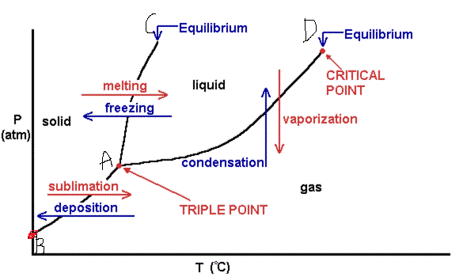

How does pressure affect my phase? Check it out in the phase change diagram above!
We assume the MP and BP are 0*C and 100*C respectively, but that is at sea level.
What happens to the BP when you go up into the mountains? Or if you drilled a hole into the Earth?
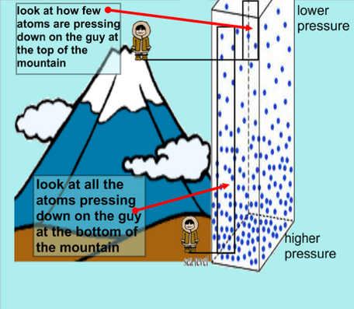

In the mountains, there are fewer air particles pushing down on you which means the atmospheric pressure is lower. If pressure is lower, then the boiling point decreases

If I drilled a hole into the Earth, the pressure would increase and the BP would increase.

