Ch 3-7: What is the periodic table? Name ___________________________
Basic Physical Science Notes S2 2019

Key Terms:
- Chemical Symbol: _______________________________________________________________
EX:
- Periodic: ______________________________________________________________________
- Group: ________________________________________________________________________
- Period: ________________________________________________________________________
Fill-in-the-blank:
- When writing a chemical symbol, the first letter is ____________, while the second letter is ___________.
- Mendeleev organized elements by increasing _________ _________.
- The Modern Periodic Table was organized by increasing ___________ __________.
- Elements that are in the same __________ have similar physical and chemical properties.
- In a period, elements on the left are ___________ and elements further to the right are _______.

Short Answer:
Circle and label a group and a period on the periodic table below.
- 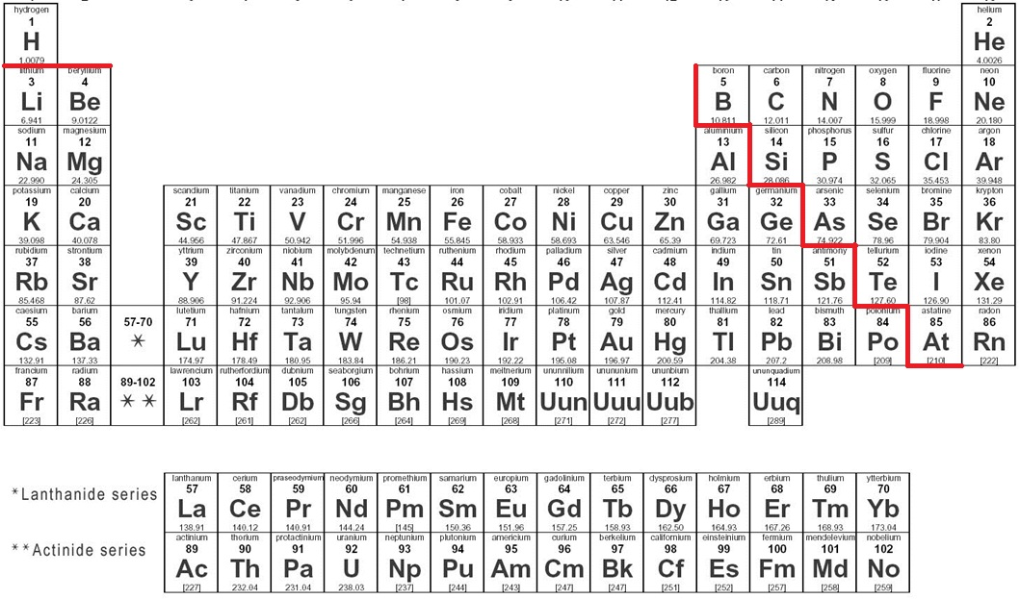
- How are elements arranged in the modern periodic table? How is that different from Mendeleev’s periodic table?
- Name that element:
Group 1, Period 3 ________ Group 4, Period 4 ________
Group 2, Period 6 ________ Group 11, Period 5 ________
Group 16, Period 2 ________ Group 18, Period 1 ________
Group 13, Period 3 ________ Group 17, Period 4 ________

Element Investigation:

Choose any 5 elements and answer the following questions about them.

- Element: _______________ Symbol _______ Atomic # _______
Mass # _____ # Protons ______ # Neutrons ______ # Electrons _____
Where is this element found in nature? ____________________________________
What is this element used for? ___________________________________________
Is this element harmful? YES NO Is this element abundant? YES NO
- Element: _______________ Symbol _______ Atomic # _______
Mass # _____ # Protons ______ # Neutrons ______ # Electrons _____
Where is this element found in nature? ____________________________________
What is this element used for? ___________________________________________
Is this element harmful? YES NO Is this element abundant? YES NO

- Element: _______________ Symbol _______ Atomic # _______
Mass # _____ # Protons ______ # Neutrons ______ # Electrons _____
Where is this element found in nature? ____________________________________
What is this element used for? ___________________________________________
Is this element harmful? YES NO Is this element abundant? YES NO

- Element: _______________ Symbol _______ Atomic # _______
Mass # _____ # Protons ______ # Neutrons ______ # Electrons _____
Where is this element found in nature? ____________________________________
What is this element used for? ___________________________________________
Is this element harmful? YES NO Is this element abundant? YES NO

- Element: _______________ Symbol _______ Atomic # _______
Mass # _____ # Protons ______ # Neutrons ______ # Electrons _____
Where is this element found in nature? ____________________________________
What is this element used for? ___________________________________________
Is this element harmful? YES NO Is this element abundant? YES NO

