Ch 13-5: What is Newton’s 2nd Law of Motion? Name ______________________________
Basic Physical Science Notes 2018

Key Terms:
- Newton: _________________________________________________________________
________________________________________________________________________

- Newton’s 2nd Law of Motion: __________________________________________________
_________________________________________________________________________
EX w/object starting at rest:
EX w/object starting in motion:

Short Answer:
- What effect does an unbalanced force have on a moving object?
- The amount by which an object accelerates depends on three things. What are they?
- Review time….What is acceleration?
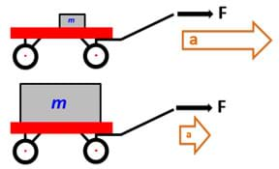
- In this picture, the same force is applied to two different wagons. One wagon holds a small mass, while the other wagon holds a larger mass. How will these two wagons accelerate compared to each other? Why?

- This picture shows a boy walking with a cart and then running with a cart. The carts have the same mass. How will these two carts accelerate compared to each other? Why?
- How much force would you have to apply to a 10-kg object to make it accelerate at a rate of 45 m/s²?
- A force of 10 Newtons is applied to a 5-kg mass. What is the object’s acceleration?

