Distance v Time AND Velocity v Time Graphs Name ____________________________________________

- Interpreting distance vs. time graphs
  - Distance or Velocity goes on the ______________________________________________

  - Time goes on the __________________________________________________
  - A flat horizontal line indicates that the object or person is __________________________________
  - A diagonal line indicates that the object or person is ________________________________________

Distance v Time Graph: Jake was on his way to his soccer game when he realized he left his shin guards at home. He turned around and went home to pick them up. On his way back to his game he had to stop and wait for a train. After the train passed he was able to drive the rest of the way to his soccer game. Explain what is occurring at each event.

AB:

BC:

CD:

DE:

EF:

Velocity v Time Graph: You’re driving down the road at a constant speed when you hear sirens coming up behind you. You notice it is a fire engine, so you slow down and pull over on the side of the road. Once it’s gone by, you speed up quickly, because you realize you’re late for your movie!

AB:

BC:

CD:

DE:

Basic Physical Science Name:
One Dim motion review Period:

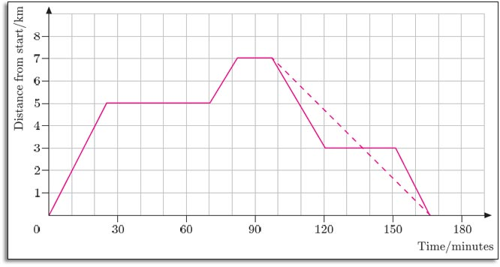

1. During what time periods is the object in the graph above moving forward?
2. During what time periods is the object in the graph above not moving?
3. During what time periods is the object in the graph above moving backward?
4. Calculate the average speed of the object for 0 to 25 minutes.
5. Why does a car traveling in a circle at a steady 60 miles/hour have a change in velocity?
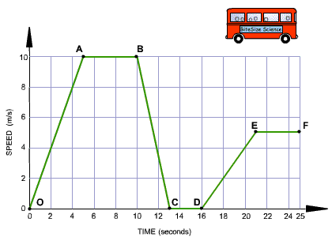
6. During what times is the object in the graph above increasing speed?
7. During what times is the moving at constant speed?
8. During what times is the bus slowing down?
9. What is the difference between a scalar and vector quantity?

