Wave Technology 2019 – Objective 3: using waves to transmit information and energy Name:

Electromagnetic waves are produced through the oscillation of a charged particle. We use many of these waves throughout our day, sometimes without even realizing it. For each of the technologies listed, find the range of wavelength used and one interesting fact.
XM radio
Range—

Interesting fact—

Cell phone reception
Range—

Interesting fact—

TV remote
Range—

Interesting fact—

Keyless entry for vehicles
Range—

Interesting fact—

Garage door opener
Range—

Interesting fact—

NFC (Near Frequency Communication)
Range—

Interesting fact—

Infrared heater
Range—

Interesting fact—

Remote engine starter
Range—

Interesting fact—

Wifi
Range—

Interesting fact—

Bluetooth
Range—

Interesting fact—

Airdrop
Range—

Interesting fact—

4GLTE
Range—

Interesting fact—

Airplay
Range—

Interesting fact—

FM radio
Range—

Interesting fact—

AM radio
Range—

Interesting fact—

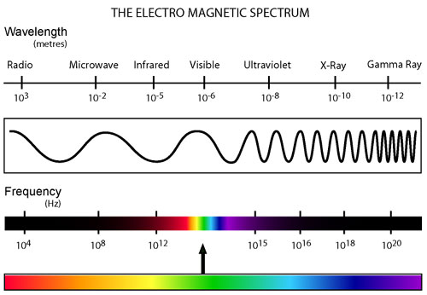

Directions: Label the different types of technology on the EM spectrum above. What do you notice?

