HPS Wave-Particle Duality of Light - 2020 Name:
Objective: Define diffraction and interference and justify how they illustrate the wave nature of light. (Obj 5) and Define photoelectric effect and justify how it illustrates the particle nature of light. (Obj 6)
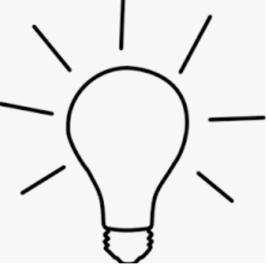
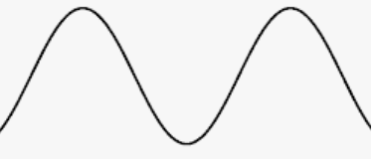
OR

- What behaviors in the image suggest that light is a wave? Explain.

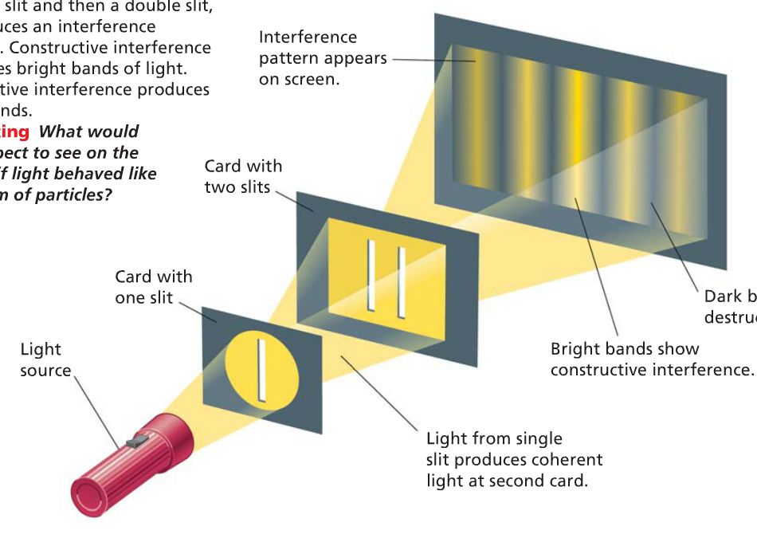

- What behavior suggests that light is a particle?
- What do you call a “particle” of light?
- What is the photoelectric effect?
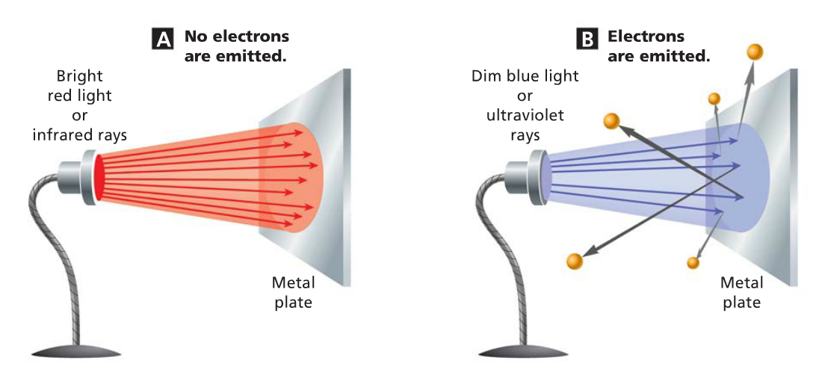
- Why are electrons emitted in image B (blue light) and not in image A (red light)?
- What is a real-life application of the photoelectric effect?

