Measurement Practice

Name:

1. What are the three parts of a measurement? Give an example.

2. How do you find the uncertainty of a measurement?

1. Measure the length of the square. Report all parts of the measurement.

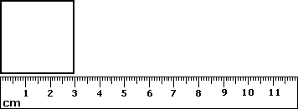

1. 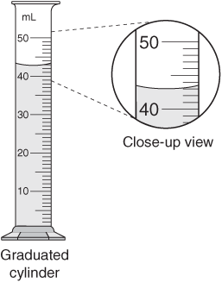Measure the mystery liquid. Report all parts of the measurement.

mL

1. Draw a measuring device that would give 7.3 ± .5 cm as a measurement.

Significant Figures and Calculation Practice

Name:

1. How many significant figures are in the following measurements?

a. 1200 kg e. 20005 sec.

b. 5060800 joules f. 2.30x104 g

c. 0.002003 g g. 2.3x105 sec.

d. 0.0005660 L h. 0.002300 g

2. Perform the following calculations and round the answer to the correct place using significant figure rules. All values represent measurements.

a. 1.72 x 0.007 e. 350 ÷ 7.89

b. 627.1 x 1.72 f. (7.0x10-2) x (3.00x104)

c. 704.050 ÷ 0.15 g. 2.003x106 + 2.10x10-2

d. 201 x 0.015 h. 56.000g ÷ 0.20