HPS – Stargazing Vocab Name _____________________________
Objective 2 Key Terms
Resources:
http://www.skyandtelescope.com/astronomy-resources/what-are-celestial-coordinates/
http://astro.unl.edu/classaction/animations/coordsmotion/radecdemo.html
http://astro.unl.edu/classaction/animations/coordsmotion/altazimuth.html
http://astro.unl.edu/classaction/animations/coordsmotion/celhorcomp.html

Directions: For each of the following terms, write the definition and sketch an image.

Declination: angular distance of a point north or south of the celestial equator (like latitude only in the sky) - Directly out from the Earth's equator, 0° latitude, is the celestial equator, 0° declination. If you stand on the Earth's equator, the celestial equator passes overhead. Stand on the North Pole, latitude 90° N, and overhead will be the north celestial pole, declination +90°.
Right ascension: like longitude only in the sky - Instead of counting in degrees, as with longitude around the Earth, right ascension is usually counted in hours, from 0 to 24 around the sky. This is just a different way of putting dividing marks on a circle. One hour in this scheme is 1/24 of a circle, or 15°.
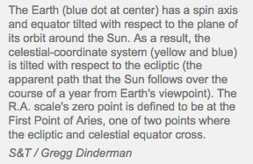
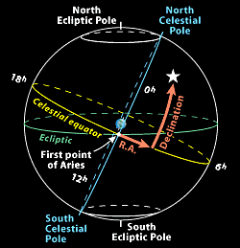

Ecliptic: a great circle on the celestial sphere representing the sun's apparent path during the year

Zenith: the point in the sky or celestial sphere directly above an observer
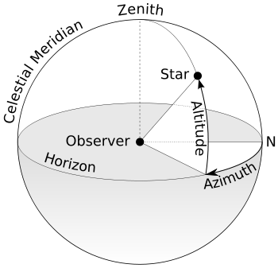

Altitude: distance an object appears to be above the horizon. The angle is measured up from the closest point on the horizon.

Azimuth: angular distance along the horizon to the location of the object. By convention, azimuth is measured from north towards the east along the horizon

North Star: Polaris, or the North Star, sits almost directly above the North Pole. Stars that sit directly above the Earth’s North or South Pole are called Pole Stars.

Southern Cross: used to find South, similar to Polaris (North Star)

Constellations: a group of stars forming a recognizable pattern that is traditionally named after its apparent form or identified with a mythological figure. Modern astronomers divide the sky into eighty-eight constellations with defined boundaries

