HPS - History of Astronomy Notes Name _____________________________

Directions: using the following scientists, create a timeline of sorts to organize Objective 1.
Hipparchus, Ptolemy, Copernicus, Brahe, Kepler, Galileo, Newton, Hubble, Penzias & Wilson

DATE | LOCATION | EVENT
~130 B.C. | Greece | Hipparchus develops the first accurate star map and star catalogue with over 880 of the brightest stars. Used sextant of sorts… People later used his work.
140 B.C. | Greece | Ptolemy “perfects” geocentric model of the solar system with circular orbits – Earth at the center, with the moon, Mercury, Venus, the Sun, Mars, Jupiter, and Saturn.
1543 A.D. | Poland | Copernicus publishes his heliocentric model of the solar system, despite the Roman Catholic Church viewing it as “heretical.” He, like Ptolemy, thought the planets had circular orbits. **Retrograde motion**
1572 A.D. | Denmark | Brahe carries out best pre-telescopic observations ever. They were the most accurate ever made with the naked eye. Invented his own model of the solar system, a combination of Ptolemaic (geocentric) and Copernican (heliocentric) systems (geoheliocentric).  Brahe’s tools link
1609 A.D. | Germany | Kepler worked for Brahe until Brahe’s death. Then he used Brahe’s data to make own model with elliptical orbits instead of round orbits. He developed Laws of Planetary Motion.  - Planets move in ellipses around the Sun.  - Planets move proportionally faster in their orbits when they are nearer the Sun.  - More distant planets take proportionally longer to orbit the Sun. (this law came later in 1619)  Was one a few vocal supporters of Galileo’s discoveries and the Copernican system.  Mainly observations, not so sure about why!
1609 A.D. | Italy | Galileo uses refracting telescope for astronomical observations. Supported the Copernican, heliocentric model. The end of his life was spent under house arrest, because his work was “heretical”. He was formally exonerated in 1992.
1668 A.D.  1687 A.D. | England | Newton designed and constructed a reflecting telescope.  His 3 Laws of Motion helped him arrive at his theory of gravity. Gravity was the force that kept the planets in their orbits.
1929 A.D. | USA | Hubble discovers universe is expanding. He found that the speed of recession of galaxies increases with distance. He explained that this is due to the expansion of the universe.  The farther away a galaxy, the faster it is moving away. V = H_{o} D
1964 A.D. | USA | Penzias & Wilson accidentally discovered cosmic microwave background radiation (CMB). CMB is the existence of radiation that permeates the entirety of the Universe and is believed to be leftover energy from the Big Bang.

KEY VOCAB: For each of the following terms, write the definition and sketch an image to help you

Geocentric: Earth-centered solar system, sometimes referred to as “Ptolemaic”

Heliocentric: Sun-centered solar system, sometimes referred to as “Copernican”

Sextant: “tool of naked eye astronomer” an instrument with a graduated arc of 60° and a sighting mechanism, used for measuring the angular distances between objects and especially for taking altitudes in navigation. Sextants for astronomical observations were devices depicting a sixth of a circle, used primarily for measuring the positions of stars.

Astrolabe – simple tool, 1 dimensional
Armillary sphere – 3D tool, specialized astrolabe
Sextant – part of armillary sphere

Parallax: the apparent shifting in position of a star due to the orbital motion of the Earth. (used to measure the distance to a star)
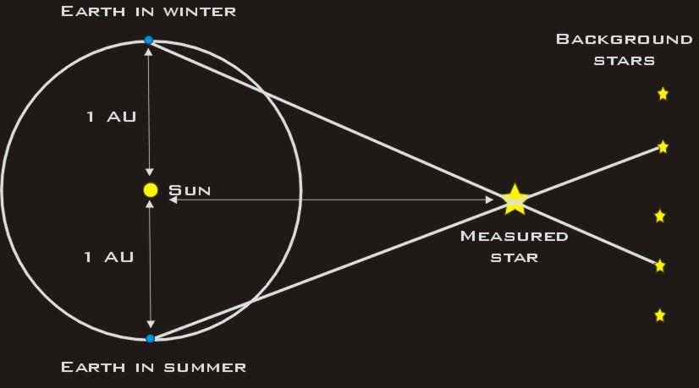

Retrograde motion: As Earth passes the slower-moving outer planets, they seem to be moving backward. When we pass Jupiter or Mars or Saturn, for example, these more outward planets in orbit – which move more slowly than Earth in orbit – appear to reverse course in our sky for a couple of months

Refracting telescope: visible light telescope invented in 1608 – uses lenses to focus light on a specific spot and then magnify the image, still used today

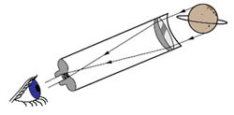
Reflecting telescope: visible light telescope invented by Newton in 1668 – uses lenses and mirrors to focus and magnify light, more widely used today

Space-based telescope: not all light can get through Earth’s atmosphere, so for some wavelengths we use telescopes aboard satellites. Benefit: clearer images than land telescopes, because the Earth’s atmosphere cannot distort the image.

Telescopes at different wavelengths: different detectors are sensitive to different wavelengths of light. EX: infrared and UV using mirrors, X rays using special designs, Gamma rays cannot be focused to telescopes can only determine the general direction from which the rays come, Radio waves use a large dish with receiver

Spectroscopy: Spectroscopy pertains to the dispersion of an object's light into its component colors (i.e. energies). By performing this dissection and analysis of an object's light, astronomers can infer the physical properties of that object (such as temperature, mass, luminosity and composition).
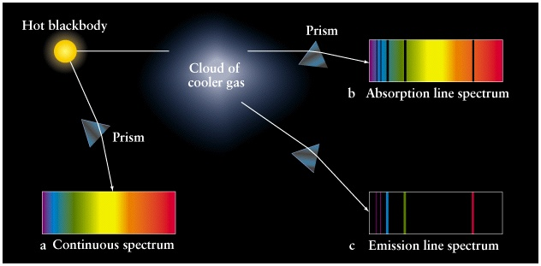
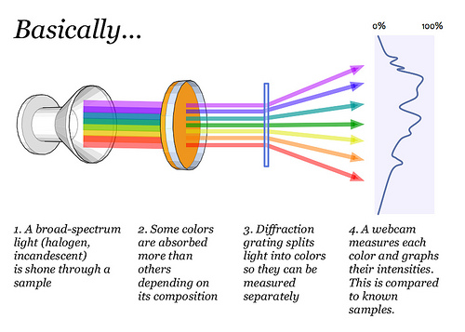

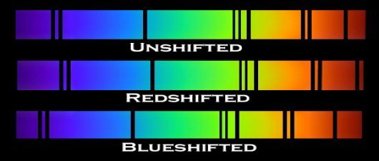

Space probes: an unmanned exploratory spacecraft designed to transmit information about its environment.

